PHYS LAB Charge & Field Instructions  
  
**A. Electrostatic Charge**

Purpose: Investigate the charging of a metal container by contact and by induction using a charge sensor.

Apparatus: PC w/interface, charge sensor w/cable assembly, glass rod, hard-rubber rod, fur, and calorimeter: jacket & lid.

You will use a charge sensor to determine the polarity of the charge producers. Then measure the amount of charge transferred to a metal container by contact and by induction.

Procedure:

**a. Charge Polarity**

1. Connect the charge sensor to analog input A, and set the gain to 1.

2. Connect the alligator clips (red and black) of the cable assembly to the calorimeter jacket, place the lid on the table, and place the calorimeter jacket on the lid.

3. Setting up the PC/interface to measure charge:   
a. Make sure that the power for the interface is turned on.  
b. Connect the charge sensor to analog input A, arrow on top.  
c. Open **PASCO Capstone** software from the desktop.   
d. Click **Hardware Setup** under Tools on the left, click on the interface input where the sensor is connected and select **Charge Sensor**. Click **Hardware Setup** again to close it.   
e. Double-Click **Graph** under Displays on the right, on theY-axis click **Select Measurement**, and select **Charge (1X) (µC)**.   
  
4. Press the 'zero' button on the charge sensor to discharge the sensor.

5. Click **Record**, if the charge is not zero; press the ‘zero’ button again.

6. Un-ground the jacket by removing the black alligator clip from the calorimeter jacket and leave it not connected.

7. Charge the hard-rubber rod with fur and lower the rod inside the jacket without touching the inside, and hold it there for few seconds and then remove it. Observe the graph display. You may need to maximize the graph display, 1st graph display button.

8. If the charge didn't come back to zero, ground the calorimeter jacket and re-zero the charge sensor. Un-ground the jacket.

9. Charge the glass-rod with fur (use the smooth side for rubbing and the rough side for holding) and lower the rod inside the jacket without touching the inside, and hold it there for few seconds and remove it. Observe the graph display.

10. Stop recording data, and enter your charge polarity data on the data sheet.

**b. Charging by Contact**

1. Click "Start", if the charge is not zero, ground the jacket and press the zero button on the charge sensor, again. Un-ground the jacket.

2. Charge the hard-rubber rod with fur and lower the rod inside the jacket, and make contact inside at many places, while turning the rod. The rod is an insulator, so you need to move the rod and make contact to transfer the charge. Just touching it won't transfer much charge. Observe the graph display.

3. Ground the jacket with the black alligator clip and then un-ground it. If the charge is not zero, press the zero button on the charge sensor, again. Data recording is still going on.

4. Charge the glass-rod with fur and lower the rod inside the jacket, and make contact inside at many places, while turning the rod. The rod is an insulator, so you need to move the rod and make contact to transfer the charge. Just touching it won't transfer much charge. Observe the graph display.

5. Ground the jacket with the black alligator clip and then un-ground it. If the charge is not zero, press the zero button on the charge sensor, again.

6. Stop recording data and enter your charging by contact data on the data sheet.

**c. Charging By Induction**

1. Click "Start", if the charge is not zero, press the zero button on the charge sensor, again.

2. Charge the hard-rubber rod with fur and lower the rod inside the jacket without touching the inside, and hold it there. While holding the rod inside, ground the jacket, then remove the ground, and then remove the rod. Observe the graph display.

3. Ground the jacket with the black alligator clip and then un-ground it. If the charge is not zero, press the zero button on the charge sensor, again.

4. Stop recording data.

5. Repeat 1-4 for the glass rod, and complete the data sheet.

**a. Charge Polarity Data:**

1. What polarity is the charge, on the rubber rod?_______on the glass rod?__________

2. What is the peak value of charge produced by the rubber rod?_____________  
 by the glass rod?_____________  
         (Use the smart tool to read)  
**b. Charging by Contact Data:**

a. What is the value of charge produced by the rubber rod?________

    b. What is the value of charge produced by the glass rod?________

**c. Charging By Induction Data:**

|  |  |  |
| --- | --- | --- |
|  | Hard-rubber rod | Glass rod |
| Peak value of charge produced while the rod is inside |  |  |
| Peak value of the induced charge |  |  |
| The polarity of the induced charge |  |  |

**d.** Draw a [series of diagrams](http://www.splung.com/content/sid/3/page/electrostatics), showing how you charged the calorimeter jacket, by induction, for any one of the rods.

Charge the hard-rubber rod with fur (diagram-1) and lower the rod inside the jacket (diagram-2) without touching the inside, and hold it there. While holding the rod inside, ground the jacket (diagram-3), then remove the ground (diagram-4), and then remove the rod (diagram-5)

**B. Electric potential lines:**

Purpose: To map the electric field lines by plotting the equipotential lines.

Apparatus: field mapping board, field plates (2), galvanometer, power supply, 4-Banana plug wires (2-red and 2-black), and probe.

Procedure:

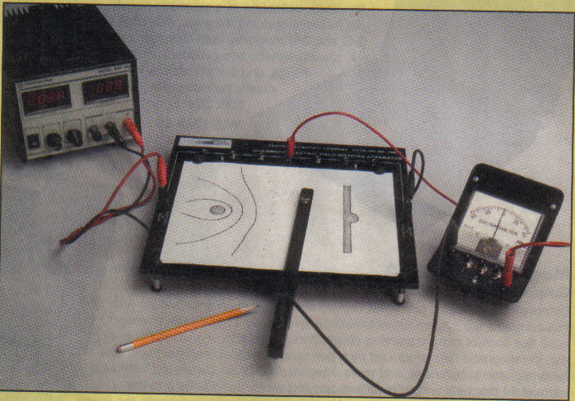

1. Place the field plate (choose the simpler patter first) on the underside of the field-mapping board and secure it to the conducting terminals using the two thumb screws provided.  
   2.  Fasten a sheet of paper on the upper-side of the field-mapping board.  (The paper is secured by depressing the board from either side and slipping the paper under the four rubber bumpers.)  
   3.  Place the design template on the two projections (template guides) above the paper and trace the corresponding template design (electrodes) on the paper.  
   4.  Connect the power source to the electrodes and mark the polarities of the electrodes. **Use 2 Volts**  
   5.  Connect the galvanometer (detector) between a slot and the terminal on the probe.  
   6.  Carefully slide the probe with the ball end facing the underside of the field-mapping board and position it between the electrodes.  Make sure the leg of the probe slides on the table top for balance of the probe.  
   7.  Move the probe toward one of the electrodes until you get no deflection on the galvanometer and draw a small circle through the hole on the probe.

8.  Now move the probe about 1cm toward one side of the paper and find another point which gives you a null reading on the galvanometer.  Repeat this until you have a series of points from one side of the paper to the other.  Look for points closer if the line is curving sharply.  Draw the equi-potential line by joining the series of points.  
  
9.  Now connect the galvanometer between another slot and the probe and repeat procedures 7 & 8.  Continue until you have equipotential lines for all the slots.  
  
10.  Draw curves perpendicular to the equipotential lines.  Name them as electric field lines, and identify their directions.



11.  Repeat procedures 1-10 for another field plate.

**C. Magnetic Field Lines:**

Purpose: To map the magnetic field lines of   
permanent magnets.

Apparatus: Two magnets: bar & horseshoe,   
compass, sheets of white paper, card-board,   
and iron-fillings.

Procedure:

1. Identify the north and south poles of the compass needle using Earth’s magnetic field.
2. Place a sheet of paper on the lab table, place a bar-magnet on it, trace the outlines of the magnet, and identify the poles (N and S) of the magnet.
3. Draw a dot somewhere near the magnet and place the head (or tail) of the compass needle over the dot.
4. Draw a dot at the location of the tail (or head) of the compass needle.
5. Move the compass needle head to this new dot, and again draw a dot at the location of the compass needle tail (or head).
6. Repeat steps 4-5 until the line meets the magnet or paper’s edge.
7. Remove the compass from the paper and draw lines connecting the dots with arrows indicating the direction that the compass points.
8. Pick another spot near the magnet and repeat the process (steps 3-7).
9. Repeat the above procedures for a horse-shoe magnet.
10. View how iron fillings line along the magnetic field by doing the following: Place the magnet on the table, place a card-board above the magnet, and place a sheet of paper on the card-board. Sprinkle iron-fillings on the paper, and tap the card-board gently.