Rotational Motion Name:_____________________ Course:_______
A. Moment of Inertia
Purpose: Determine the moment of inertia of regularly shaped objects, a disk and a ring, using the Rotary Motion Sensor.
Apparatus: Rotary motion sensor with step pulley, super pulley, gray disk, black ring, vernier caliper, thread, 20-g mass, 600-g electronic balance, interface, and PC.
Theory: A hanging mass of 20-g will be used to rotate the disk. As the 20-g mass goes down with a linear acceleration (a) the disk will move with an angular acceleration of α. Linear acceleration is given by, a = rα, where r is the radius of the outer step-pulley. An expression for the experimental moment of inertia, I_{E} is obtained as follows.
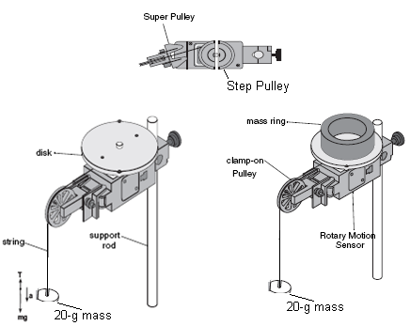
Applying Newton second law for the 20-g mass will yield----> mg - T = ma-------(I)
Applying Newton's second law for the rotational motion will yield-------->
T.r = I_{E} α = I_{E} (a/r)------(II)
Eliminating T from the above two equations will yield--------> I_{E} = mr² (g/a - 1).
Procedure:
1. Find the mass of the gray disk and the mass of the black ring using the electronic balance.
2. Find the dimensions of the ring & disk using the vernier caliper. Check your measurements with the instructor.
3. Connect the rotary motion sensor to the 750 interface by inserting the yellow plug into digital channel-1 and the black plug into digital channel-2.
4. Mount the Rotary Sensor onto the lab stand so that the step pulley is on top. Clamp-on the Super Pulley on the end of the sensor (end where the cord is) as shown in theory.
5. Cut a piece of thread, about 50cm in length. Tie one end to the outer step pulley and the other to a 20-g mass and hang it over the super pulley.
6. Setting up the Interface for data collection:
a. Open PASCO Capstone software from the desktop. If the Buy Key/ Enter Key window pops up, close it.
b. Click Hardware Setup under Tools on the left, click on the interface input where the sensor is connected and select Rotary Motion Sensor. Click Hardware Setup again to close it.
c. Double-Click Graph under Displays on the right, click Select Measurement, and select Velocity.
7. Turn the step-pulley clockwise so that the thread winds around the outer groove of the step pulley and hold it.
8. Click "Record" and release the step-pulley. Stop the data collection.
9. Using the linear portion of the Velocity VS. Time graph, obtain the acceleration by curve fitting the data.
10. Remove the thumb screw and attach the gray disk into the top of the step-pulley. Re-attach the thumb screw.
11. Repeat procedures 7-9.
12. Place the black ring on top of the disk, and repeat procedures 7-9.
13. Calculate the experimental moment of inertia, I_{E}, and the theoretical moment of inertia, I_{T} and complete data table II.
DATA
Mass of the gray disk = M = ______________
Mass of black ring = M₁ = ________________
Table I: Dimensions of the step pulley, ring & disk
 | Diameter (cm) | Radius (cm)
Step pulley (outer) | 4.76 | r = 2.38
Inside of black ring |  | R₁ =
Outside of black ring |  | R₂ =
Gray disk |  | R =
The hanging mass, m = 20-g and the outer step pulley radius, r = 2.38 cm can be used to re-write I_{E} as follows. This expression will be used to calculate I_{E} in Table II, below.
I_{E} = mr² [(g/a) - 1] = 20*2.38²[(g/a) - 1] =113 [(g/a) - 1].
Table II:
 | Acceleration, a (m/s²) | I_{E}, Exptal*(g.cm²) | I_{T}, Theory**(g.cm²) | % Difference
Pulley alone |  |  | XXXXXXXXXXX | XXXXXXX
Pulley & Disk |  |  | XXXXXXXXXXX | XXXXXXX
Disk | XXXXXX
Pulley, Disk & Ring |  |  | XXXXXXXXXXX | XXXXXXX
Ring | XXXXXX
**I_{T} (disk) = 0.5 MR²; **I_{T} (Ring) = 0.5 M₁(R₁² +R₂² ).
*I_{E}, for the disk is obtained by subtracting the pulley value from the pulley & disk value.
B. Conservation of Angular Momentum
Purpose: Verify the conservation of angular momentum using the Rotary Motion Sensor.
Apparatus: Rotary motion sensor with step pulley, gray disks, interface, and PC.
Theory: In this part you will rotate a disk attached to the rotary motion sensor and let the PC collect the data. While the first disk rotates, a second disk will be dropped onto the first disk. The PC will continue to collect the data. From the display the initial and final angular velocities can be obtained. In this case, there is no net torque, and hence the angular momentum should be conserved.
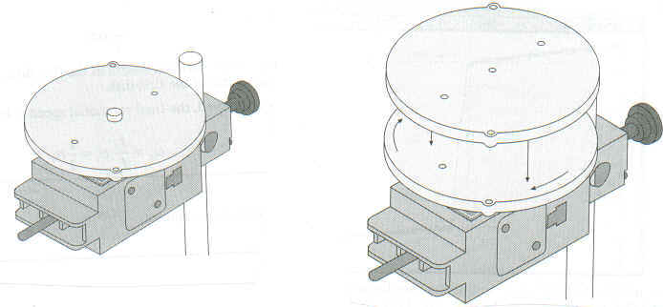
Conservation of angular momentum gives-------> I_{i}ω_{i} = I_{f}ω_{f}
The initial and final moments of inertia can be obtained from Part A.
Procedure:
1. The rotary motion sensor is connected to the interface. Remove the black ring and gray disk. Remove the super pulley and the string from the rotary motion sensor.
2. Screw in the gray disk onto the rotary motion sensor.
3. Setting up the Interface for data collection:
a. Open PASCO Capstone software from the desktop. If the Buy Key/ Enter Key window pops up, close it.
b. Click Hardware Setup under Tools on the left, click on the interface input where the sensor is connected and select Rotary Motion Sensor. Click Hardware Setup again to close it.
c. Double-Click Graph under Displays on the right, click Select Measurement, and select Angular Velocity.
4. Spin the gray disk counter-clockwise, then click Record.
5. Let the PC collect some data, then drop the second disk onto first disk, and let the PC collect some more data.
6. To determine the initial and final angular velocities, use the Show coordinates Tool found on tool bar. Drag the pointer to the data entry that was recorded just before the second disk was dropped. The Y coordinate is the angular speed. The final angular speed is found in the same fashion, this time dragging the Smart Tool to the data entry just after the second disk was dropped. Record both angular velocities.
7. Repeat steps 4 -6, 2 more times and complete the data table.
DATA (Include units)
ω_{i} | ω_{f} | I _{i} | I _{f} | L_{i =} I_{i}ω_{i} | L_{f} = I_{f}ω_{f} | % Difference
Write a conclusion for the second activity, conservation of angular momentum.

