Global Warming
Anthropogenic Global Warming
Climate Change

“Greatest threat to humankind!”

Proven…?
Debate is Over?

97% of scientists say manmade climate change is real.

97% of scientists say manmade climate change is real.
The claim that “97% of scientists agree” is in part based on 77 anonymous scientists who responded to a survey. The survey started by seeking opinions from 10,257 scientists. However, only 77 responded. So the 97% “consensus” claim is not based on thousands of scientists or even hundreds of scientists – but only on 77. Out of those 77 scientists, 75 answered the survey to form the mythical 97% “consensus.

Policy makers continue to make this statement…..

Thousands of scientists around the world who research this, dispute the claim, including the founder of The Weather Channel.

Theory:
an idea that is suggested or presented as possibly true but that is not known or proven to be true
Hypothesis:
an idea or theory that is not proven but that leads to further study or discussion
Fact:
something that truly exists or happens : something that has actual existence: proven
Scientific Method:
principles and procedures for the systematic pursuit of knowledge involving the recognition and formulation of a problem, the collection of data through observation and experiment, and the formulation and testing of hypotheses
Carbon dioxide is identified an airborne contaminant and regulated by the United States Environmental Protection Agency.

During the past 4 years, the EPA designated carbon dioxide to be a greenhouse gas, a pollutant, like methane, nitrous oxide, sulfur dioxide (add much greater effect in greenhouse gas than carbon dioxide, methane ~25 times greater), and began preparing regulations to limit and control carbon dioxide emissions from coal burning power plants. EPA was sued, and Supreme Court ruled that the regulations for air quality are EPA’s jurisdiction, and declined to rule thereby making EPA’s ruling stay.

Carbon dioxide is a claimed to be a greenhouse gas and concentrations in the atmosphere have been rising steadily.

From 1996 to 2014, carbon dioxide concentrations increased from 260 to 390 parts per million, 0.18% over 18 years or 0.01%/year.

Data from Hawaii shows this.
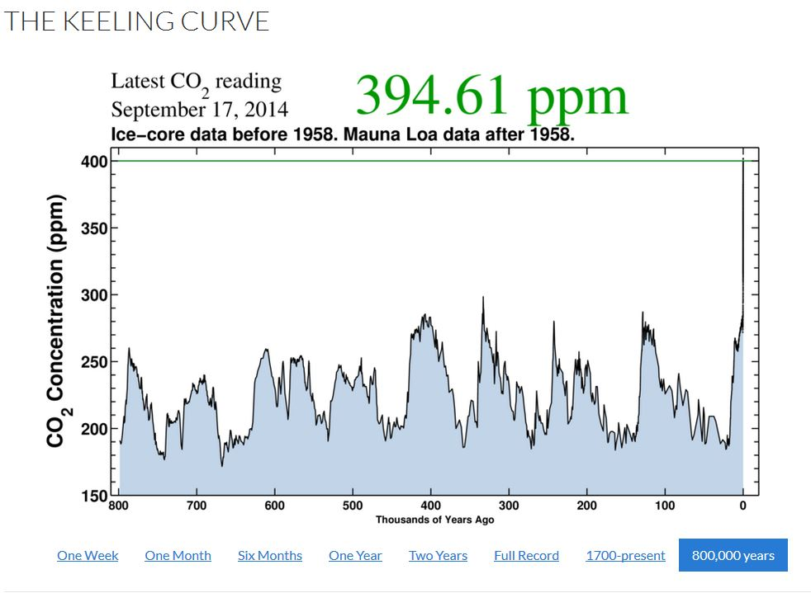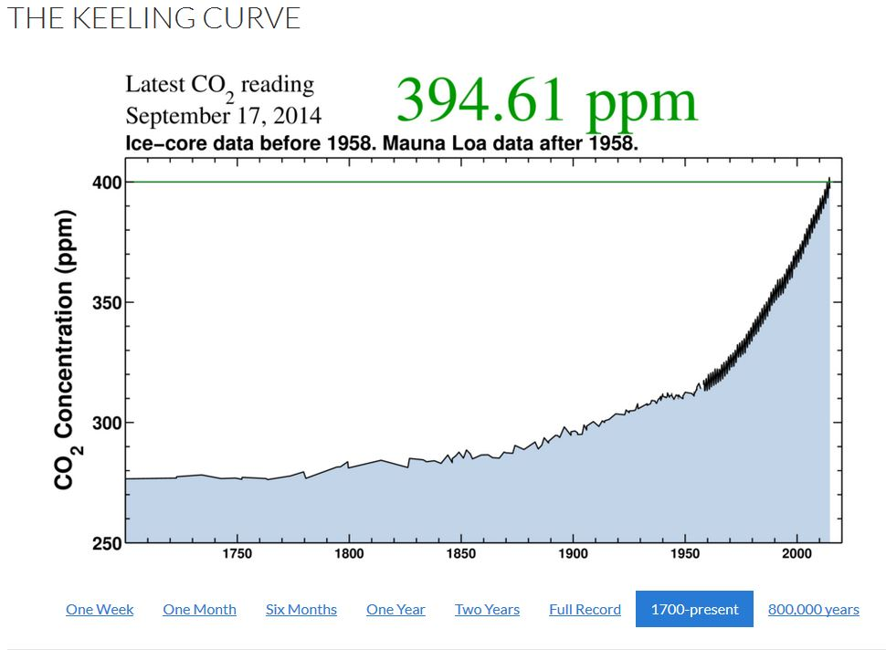
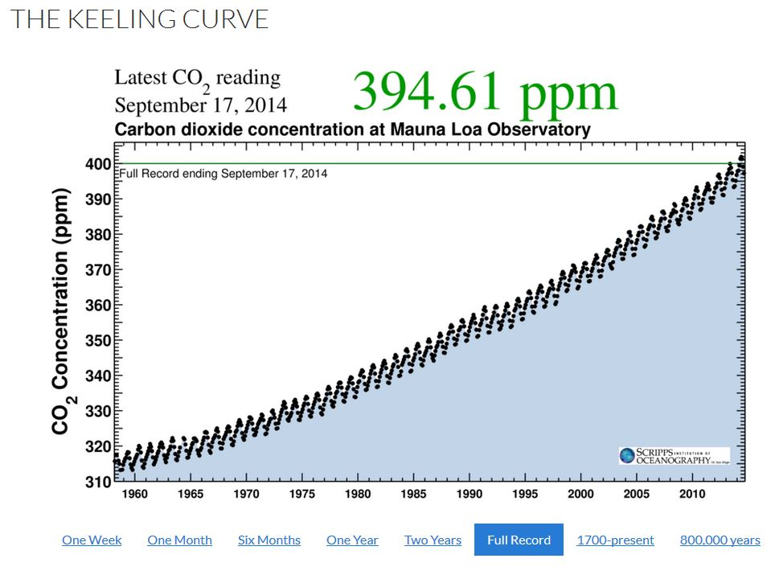

If Carbon Dioxide is a cause of global warming, and concentrations have continued to increase as demonstrated by real data, then do you think that temperatures would be expected to increase also, and in the same proportion?

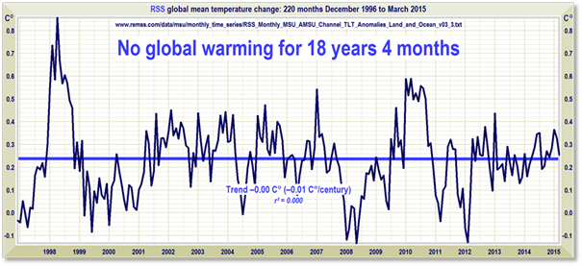

International Panel on Climate Change (United Nations)
Multiple computer models. Accurate Predictions?
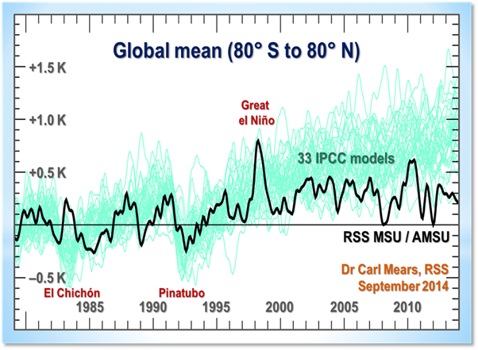
Computer models predicting climate decades into the future. How accurate are the weather predictions weeks or months into the future?
Climate complex with hundreds of factors.
Main factor: the Sun. Other Factors:
volcanoes, tilt of the Earth’s axis, water vapor, methane, clouds, ocean cycles, plate tectonics, shifting ocean currents, albedo (Earth’s changing reflective properties), atmospheric dust, atmospheric circulation, cosmic rays, particulates like carbon soot and volcanic dust, forests and grasslands, urban and other land use changes. Climate change is governed by hundreds of factors, not just CO2.

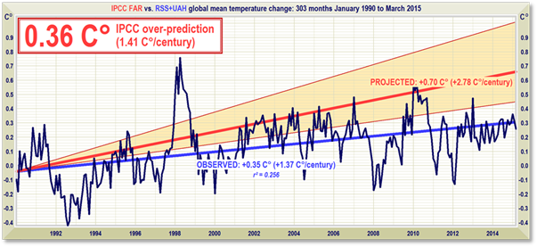
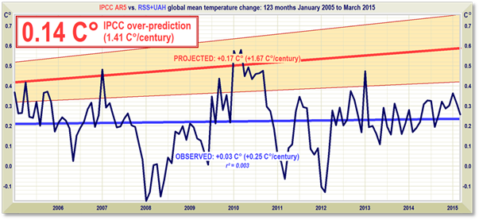
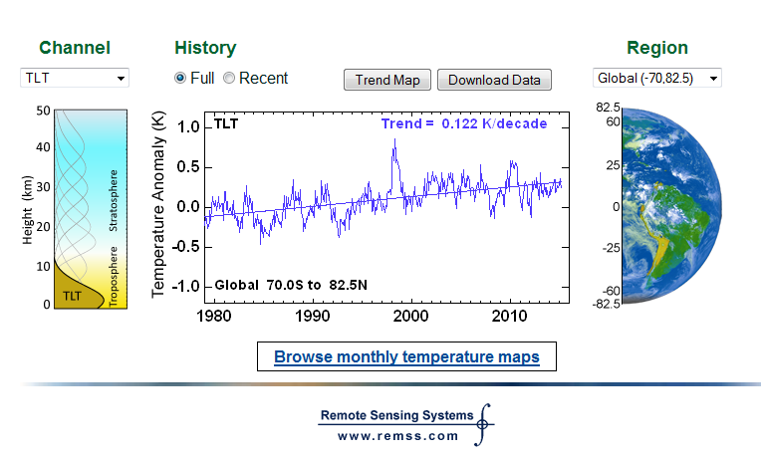

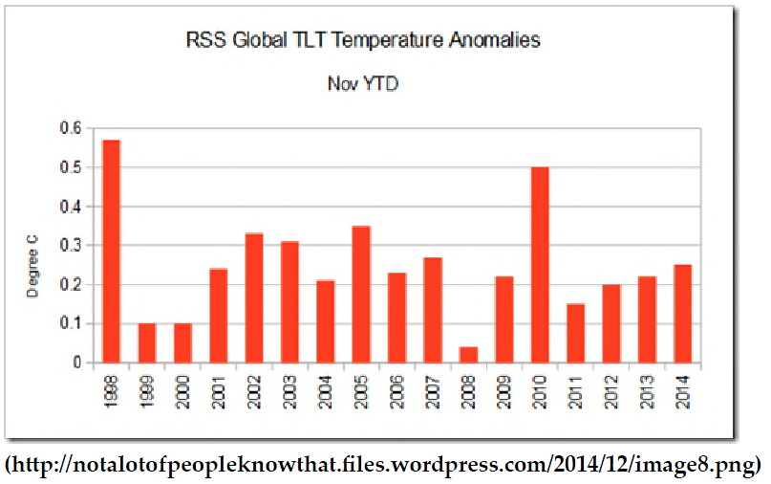
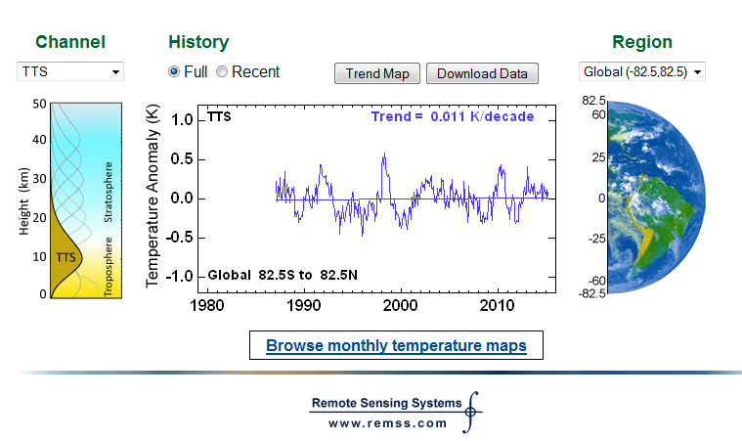

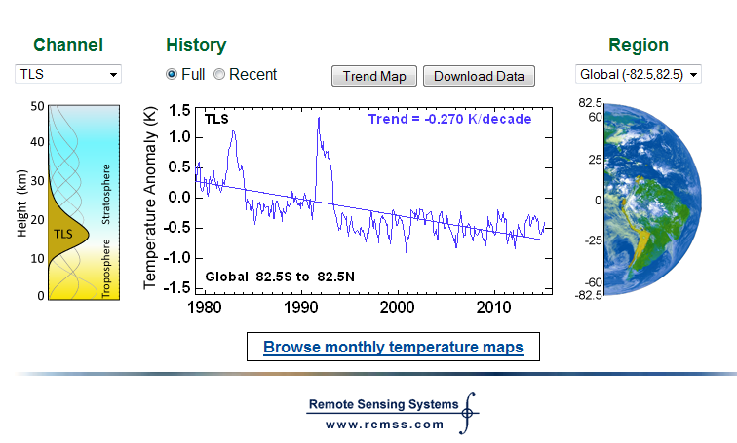

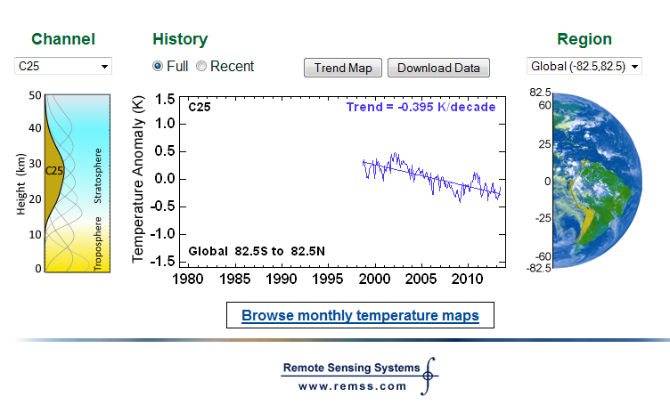

Medieval Warm Period from AD 950 to 1250. The Center for the Study of Carbon Dioxide and Global Change reported in 2009 that “the Medieval Warm Period was (1) global in extent, (2) at least as warm as, but likely even warmer than, the Current Warm Period, and (3) of a duration significantly longer than that of the Current Warm Period to date.”
The Science and Public Policy Institute reported in May 2009: “More than 700 scientists from 400 institutions in 40 countries have contributed peer-reviewed papers providing evidence that the Medieval Warm Period (MWP) was real, global, and warmer than the present. And the numbers grow larger daily.”
Greenland was populated by people from Scandinavian countries (Vikings) for years, that farmed (crops and animals).
The extent of sea ice continues to decrease?
Artic ice projected to be gone by 2050.
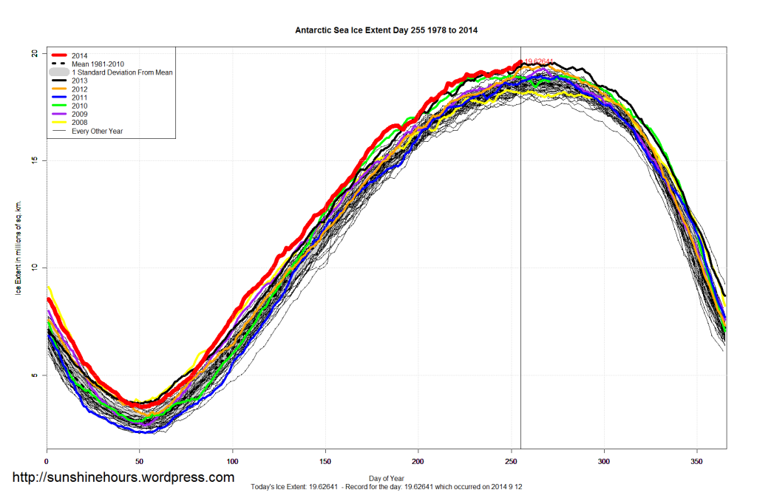
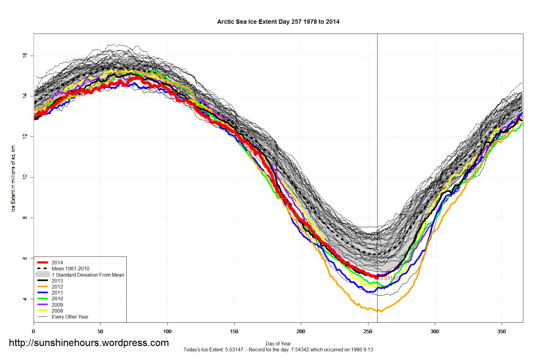
Sea levels are rising around the globe. Is the rate of rise is increasing due to increased carbon dioxide emissions?
1900 – 2000, 18 cm (7.1 in) in 100 years
0.18 cm/yr (0.07 in/yr).

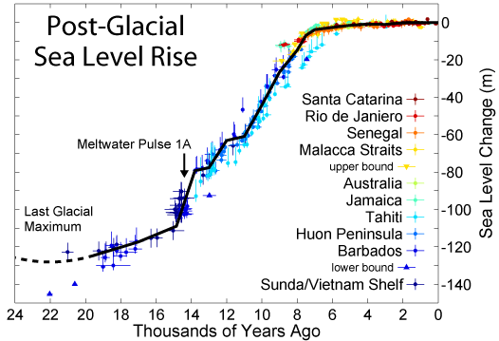
425 Feet
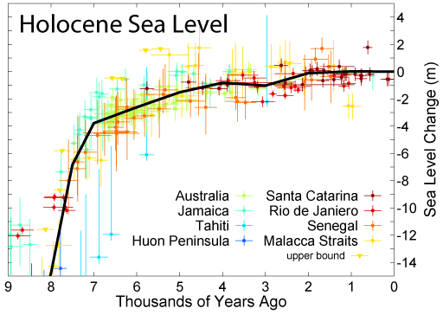
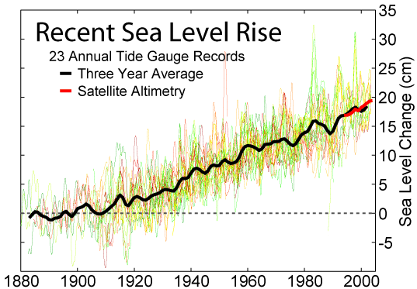
18 cm = 7.1 inches
Sea levels have been rising since the last ice age ended more than 10,000 years ago. There is currently no acceleration in sea level rise.
Global sea levels have been naturally rising for ~20,000 years and have decelerated over the past 8,000 years, decelerated over the 20th century, decelerated 31% since 2002, and decelerated 44% since 2004 to less than 7 inches per century. There is no evidence of an acceleration of sea level rise, and therefore no evidence of any effect of mankind on sea levels.
According to tide gauges, sea level is rising LESS than the thickness of one nickel (1.95 mm thick) per year or about the thickness of one penny (1.52 mm thick) a year. According to satellite info it is rising slightly more than two pennies a year (3.04 mm).
The number of severe weather events (major hurricanes, tornadoes, draughts, floods, etc.) hitting the United States have increased over the past few years.
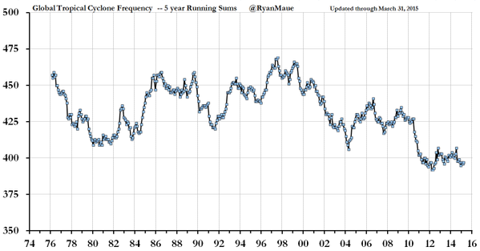

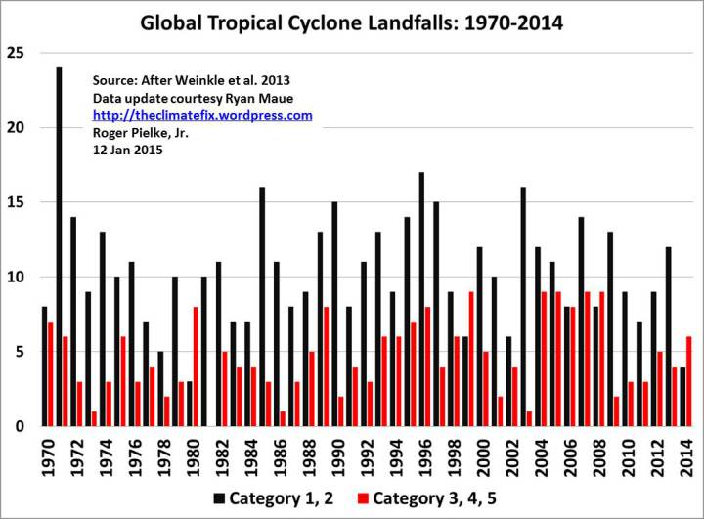
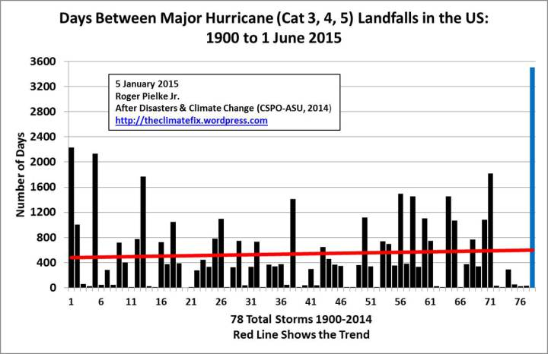

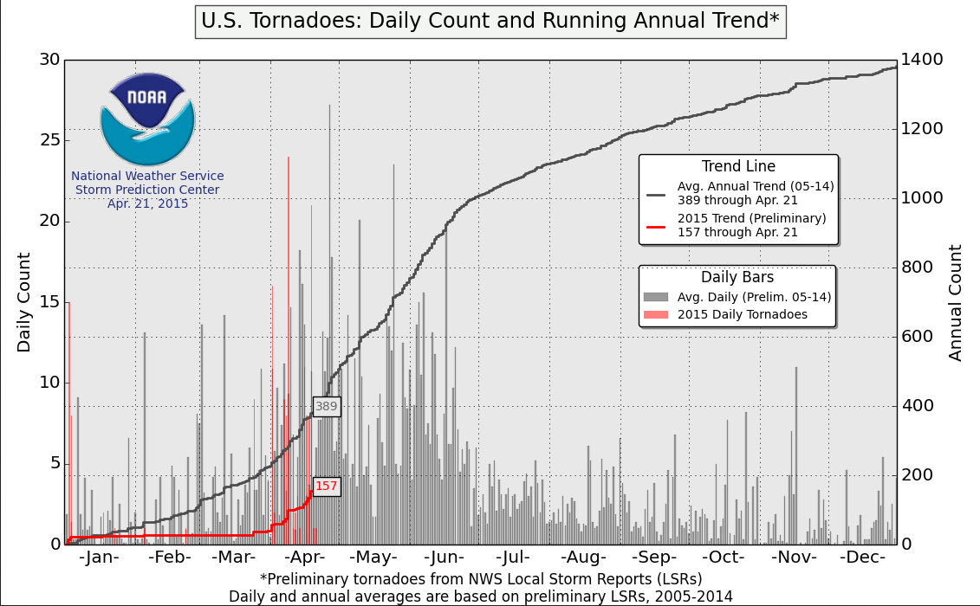

Millions of dollars spent in research to “prove” that carbon dioxide emissions by humans are causing Global Warming. By researchers and policy makers that tend to profit from the research.

Billions of dollars expected to be spent to meet proposed regulations to slow or stop global warming caused by carbon dioxide emissions.

Slow down or stop economic growth that can help people get out of poverty and improve standard of living.
Estimated 50 to 1 cost to try and stop global warming compared to adapting.

Question: Is science used to make public policy, or is it based on a political agenda?

Finally, do not believe everything you see or hear, but check it out for yourself.

