Equations of kinematics for constant acceleration: (acceleration due to gravity = 9.8 m/s2, down)

Final velocity = *v*, Initial velocity = *v0*, Acceleration = *a*, Time interval = *t*, Displacement = *Δy = y-y0*

|  |  |  |  |  |
| --- | --- | --- | --- | --- |
| 1. | 2. | 3. | 4. | 5. |
|  |  |  |  |  |

1. A coin is dropped from a high-rise building (height = 200 m).   
a. How long will it take for the coin to reach the ground?  
b. What will be the speed of the coin as it reaches the ground?

2. A ball is tossed, vertically up with an initial speed of 15 m/s. How high it will rise?

3. A rifle is aimed horizontally at a target 50 m away. The bullet hits the target 2.0 cm below the aim point.  
a. What was the bullet’s flight time?  
b. What was the bullet’s speed as it left the barrel?

4. A rescue plane flies at 200 km/h and constant height, h = 500 m.   
How far horizontally away, the pilot needs to release the rescue   
capsule, in order for the capsule to land near the victim.

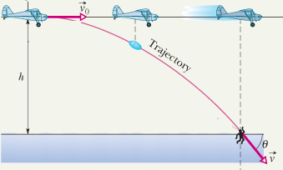

|  |  |  |
| --- | --- | --- |
|  | |  | | --- | |  |   5. A football player punts the football so that it will have a “hang time” (time of flight) of 4.5 s and land 46 m away. If the ball leaves the player's foot 150 cm above the ground, what must be the (a) magnitude and (b) angle (relative to the horizontal) of the ball's initial velocity? |