Conductivity of a metal wire
Purpose: To measure the conductivity of a metal wire using a digital multi meter (DMM).
Apparatus: DMM, one long metal (nichrome) wire (≈100 cm), connector box, micrometer, and meter stick.
Theory: Resistance, R of a metal wire of length L and cross-sectional area A is given by:
$R=\frac{L}{σA}$
The plot of R versus L will yield a slope of, $\frac{1}{σA}$ . Knowing A, the conductivity, σ can be determined.
Procedure:
Variation of resistance with length:
- Set the DMM to measure resistances and connect it to the connector box.
- Connect one end of the long metal wire to one of the terminals of the connector box.
- Measure 10 cm length of wire, (do not cut the wire) and connect it to the other terminal so that there is exactly 10 cm of wire between the terminals.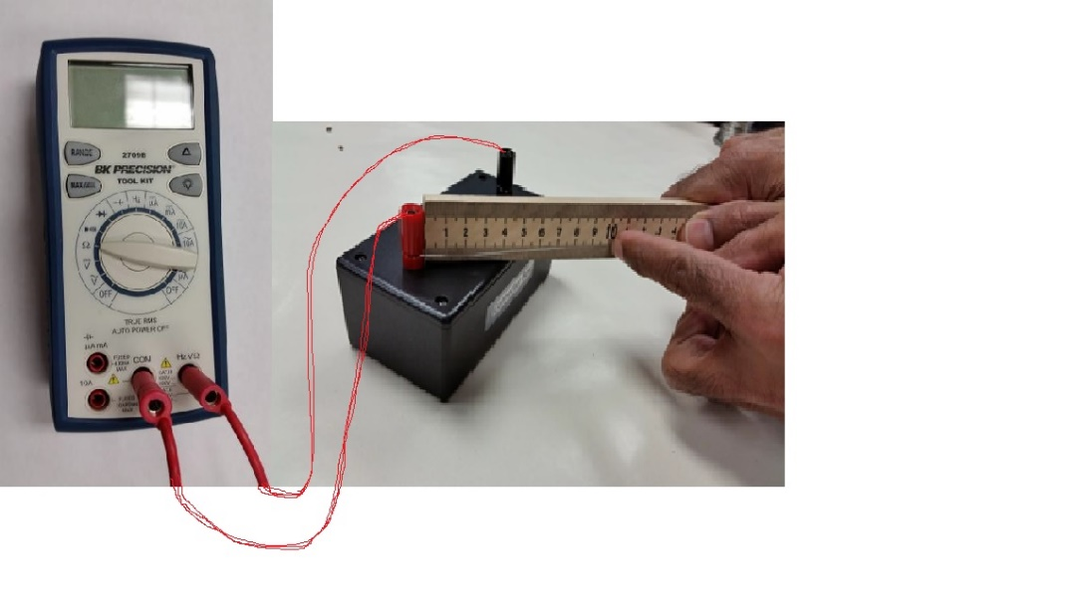
- Record the resistance value and repeat the above procedure for other lengths: 20, 30, 40, 50, 60, 70, 80, 90, 100 cm.
- Plot a graph, R versus L, determine its slope, and attach the graph to your report.
- Measure the diameter of the wire with a micrometer, calculate the cross-sectional area, and calculate the resistivity of the metal.

Variation of resistance with diameter:
- Fold the wire into half and then again half to make 4 equal pieces.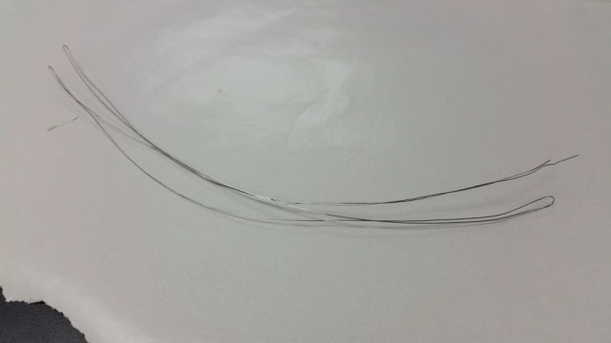 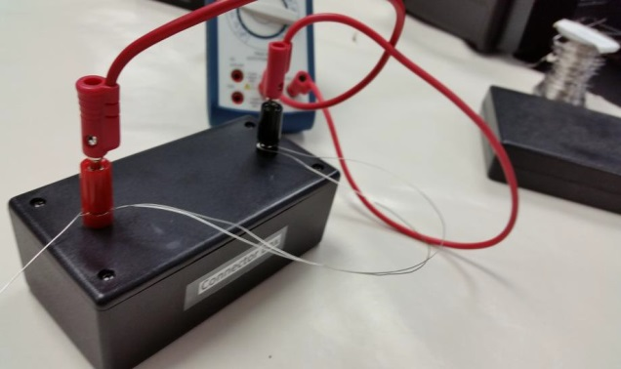
- Measure the resistance of one fold, two folds, three folds, and four folds.
- Tabulate your data, plot an appropriate graph, and see what happens.
- Add an appropriate trend line, and obtain resistivity from your fit.
- Attach your graph to the report.
DATA
Variation of resistance with length:
Slope of R versus L, graph:_________________
Diameter of wire = __________________ Cross-Sectional area of wire =________________
Experimental conductivity of wire = _________________
Accepted conductivity of wire = 1.00 x 10⁴ mhoohm.cm. % Error = __________________
Variation of resistance with diameter:
Coefficient of the fit = _________________
Length of wire = __________________ Cross-Sectional area (for 1 fold) =_______________
Experimental conductivity of wire = _________________
Accepted conductivity of wire = 1.00 x 10⁴ mhoohm.cm. % Error = __________________
Conclusion:

