PHYSICS TEST ITEMS
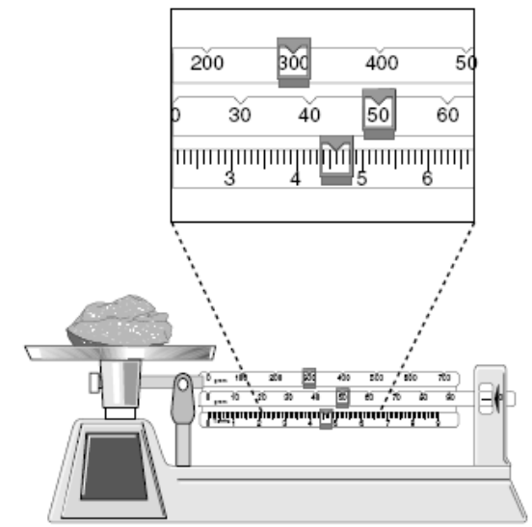
1. What is the mass of the rock?
a. 335.6 g c. 350.6 g
b. 354.6 g d. 356.0 g

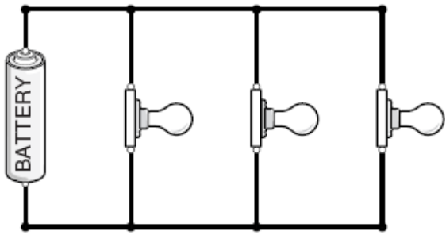
2. Which of the following is shown in this diagram?
a. alternating current c. series circuit
b. short circuit d. parallel circuit

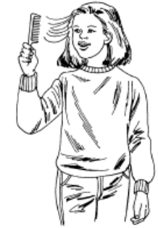
3. Objects with like charges repel and unlike charges attract. The girl's hair and the comb have
a. unlike charges c. neutral charges
b. like charges d. no charges

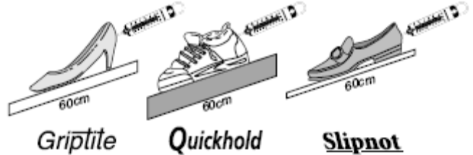
4. The picture shows a test for non-slip surfaces to be used on a ramp. Which of these must be done to provide more
meaningful results?
a. use the same shoe on each surface c. use the same shoe size for each type of shoe
b. use boards of the same thickness d. use shoes with shoes designed for sports

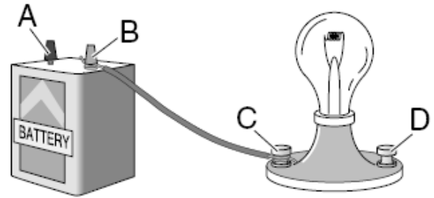
5. In order to turn on the light, a piece of wire needs to be connected from
a. A to C c. B to C
b. A to D d. C to D

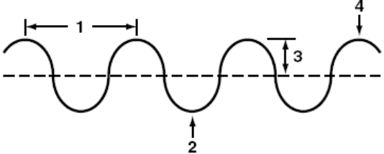
6. The area that shows the amplitude of the wave is
a. 1 c. 3
b. 2 d. 4

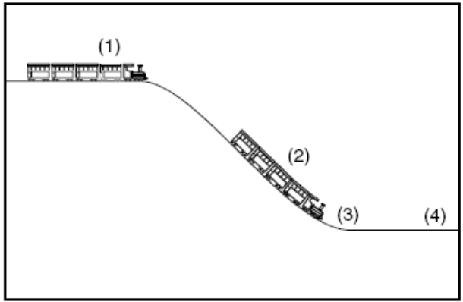
7. The location on the track where the train has the greatest potential energy is
a. 1 c. 3
b. 2 d. 4

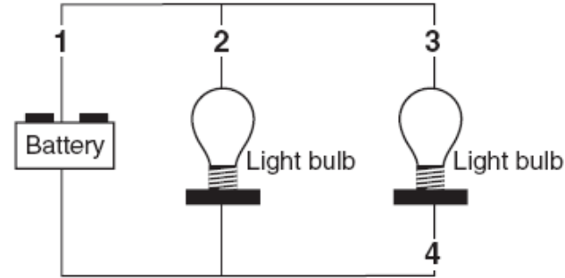
8. Both light bulbs are lit in the circuit above. In order to turn off both lights, a switch must be placed in the circuit at the location marked
a. 1 c. 3
b. 2 d. 4

9. Which diagram best shows the reflection of light?
a. 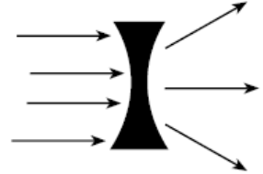 c. 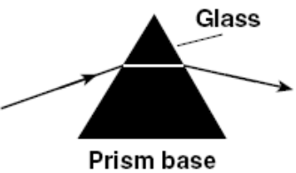

b. 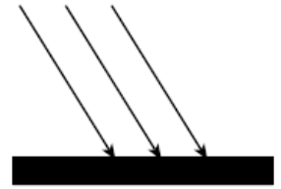 d. 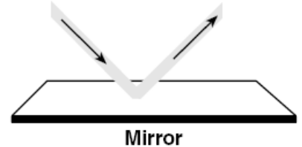

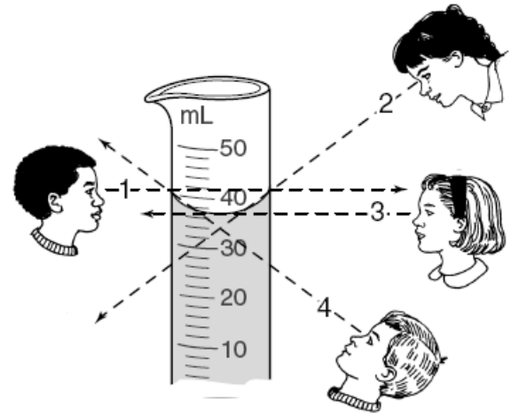
10. The diagram shows a graduated cylinder containing water. From which position will the most accurate measure of the
volume of the water be made?
a. position 1 c. position 2
b. position 3 d. position 4

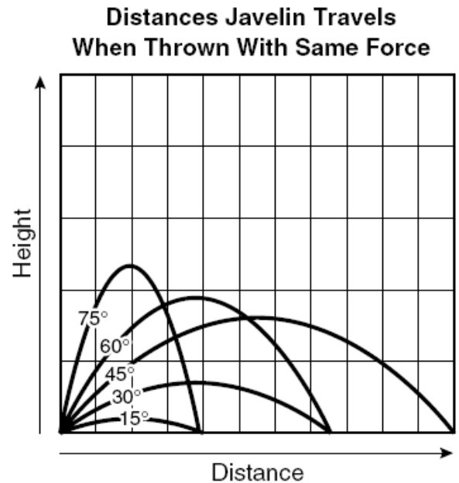
11. According to the graph, which angle of release would cause the javelin to go the farthest?
a. 75º c. 45º
b. 60º d. 30º

12. The Earth makes a complete rotation once every 24 hours. Which of these would best illustrate rotation?
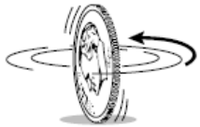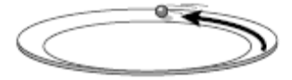
a. coin spinning c. marble going around the edge of a plate

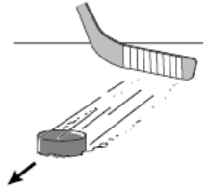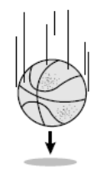
b. puck sliding on the ice d. basketball falling

13. Density = 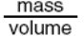 Mass = 12 g
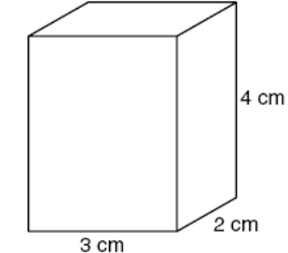
The density of this box is
a. 0.5 g/cm³ c. 1.5 g/cm³
b. 1.0 g/cm³ d. 2.0 g/cm³

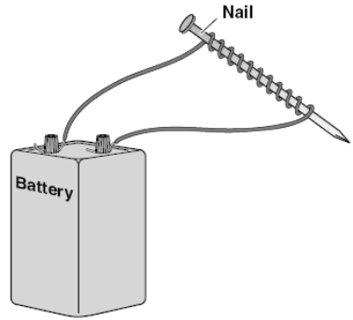
14. The picture shows how to make an electromagnet. Which of these would make the electromagnet strongest?
a. using a longer wire from the battery to the nail c. wrapping the wire around a nonmetallic object
b. wrapping the wire around the nail more times d. making the loops of wire less tightly coiled

15. Which diagram shows the refraction of light as it enters water from the air?
a. 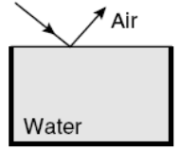 b. 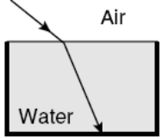 c. 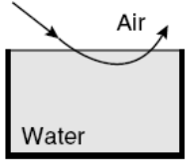 d. 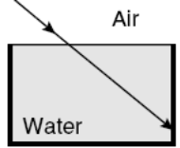

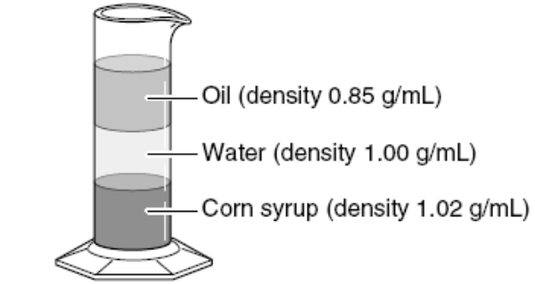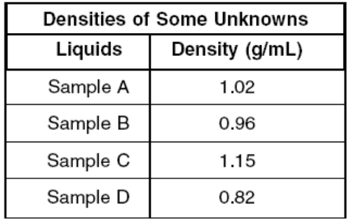
16. Students measured and recorded the density of 4 samples. Using the density column and data table shown above,
which of the samples will probably float on top of the oil?
a. sample A c. sample C
b. sample B d. sample D

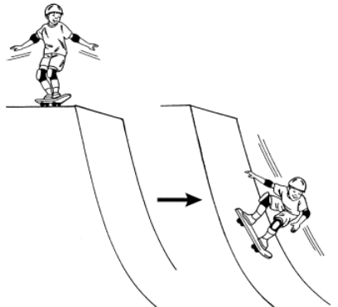
17. Which type of energy change is occurring in the pictures above?
a. mechanical energy to chemical energy c. chemical energy to heat energy
b. potential energy to kinetic energy d. solar energy to nuclear energy

18. A skater traveled along a straight line. The graph below shows the distance the skater
traveled from the starting point during a period of time.
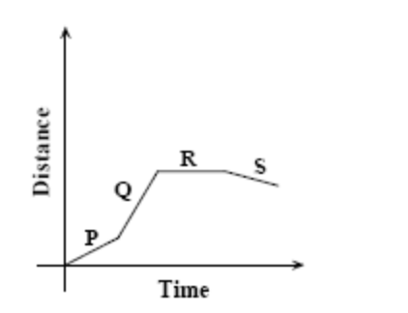
Which labeled section of the graph represents the time during which the skater was moving forward with the LEAST
speed?
a. P c. R
b. Q d. S

19. In the situation shown below, a pulley system with a mechanical advantage of 2.0 is attached to a lever so that a
downward force is exerted on one end.
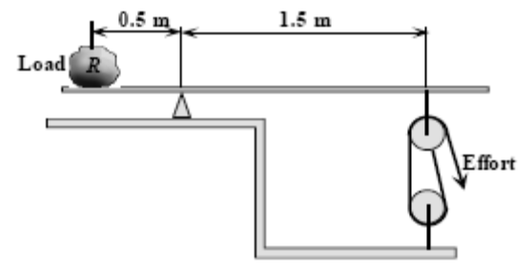
Neglecting friction, what effort must be applied to the pulley in order to lift rock R, which weighs 1,200 newtons?
a. 200 newtons c. 400 newtons
b. 300 newtons d. 600 newtons

20. The diagram below is a complete circuit.
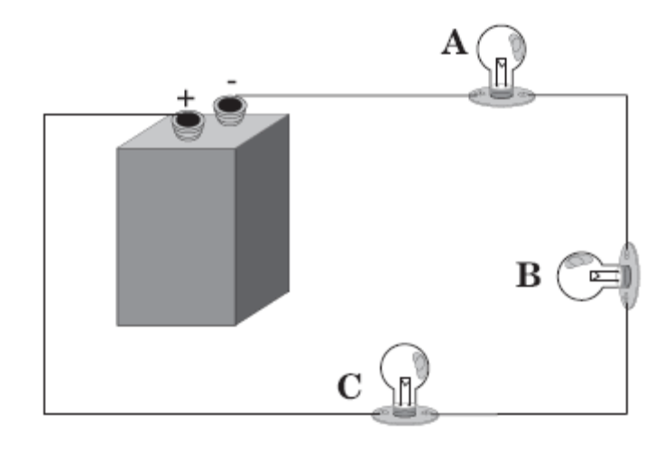
What will occur when bulb B is unscrewed?
a. All bulbs will go out. c. Only bulb C will continue to be lit.
b. Only bulb A will continue to be lit. d. Bulbs A and C will continue to be lit.

21. An object with a mass of 5 kg experiences a force as shown in the graph.
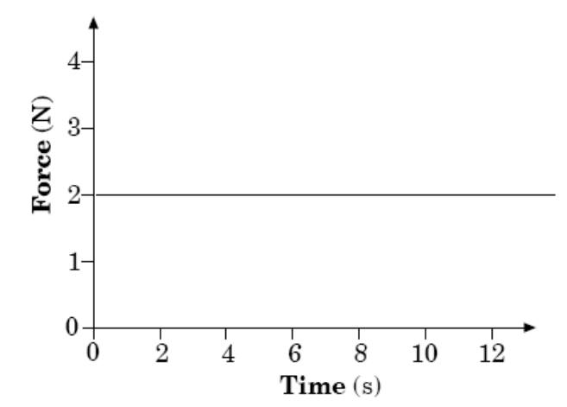
What is the change in velocity after 10 s?
a. 2 m/s c. 10 m/s
b. 4 m/s d. 20 m/s

22. The drawings below show four pairs of ice skaters skating at different velocities. In which of the following situations
is the momentum equal for the two skaters?

a. 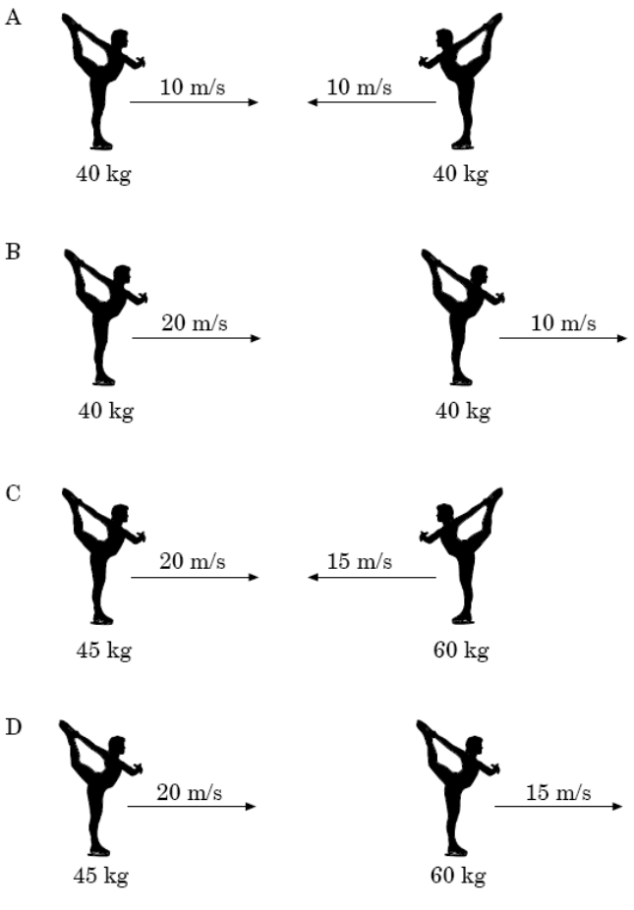 .

b.

c.

d.

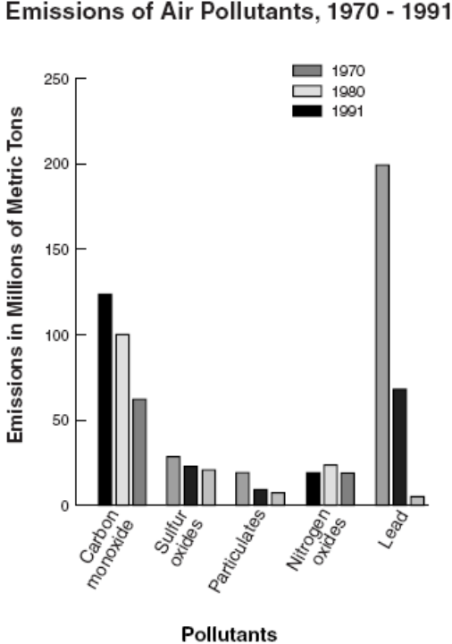
23. According to the graph, which air pollutant decreased the most from 1970 to 1991?
a. carbon monoxide c. particulates
b. sulfur oxides d. lead

24. In the diagram, what essential part of an electric circuit is missing at position X?
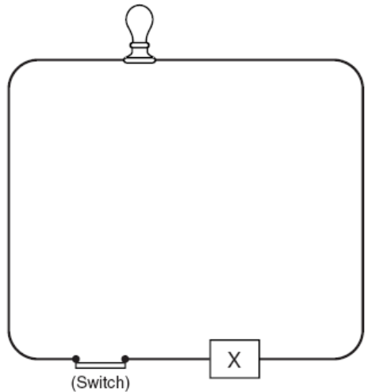
a. load c. wires
b. on/off switch d. source of current

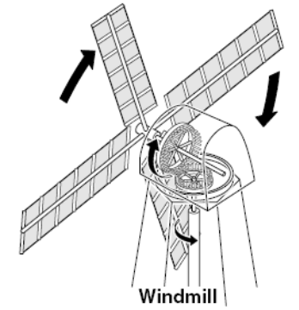
25. What type of energy does the windmill use to do work?
a. mechanical
b. nuclear
c. chemical
d. electrical

26. Which of these would be the best way to prove that a pine stick is more flexible than an oak stick?
a. 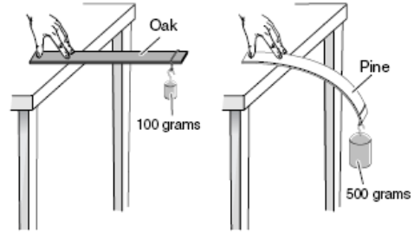 c. 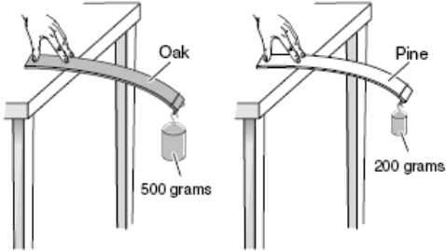

b. 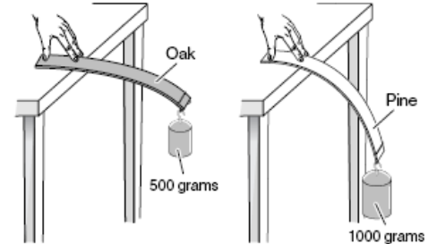 d. 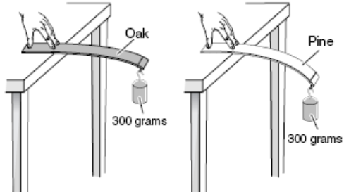

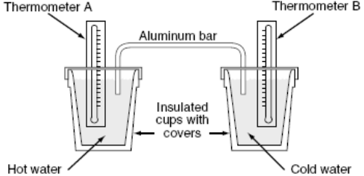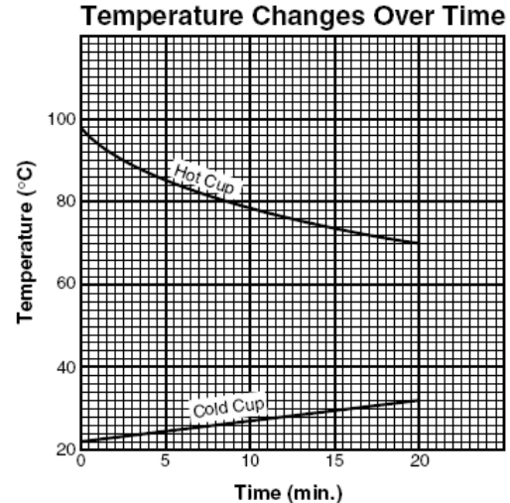
27. The above apparatus was set up as shown, and thermometer readings were recorded for 20 minutes. The results were
then graphed. By how many degrees did the temperature of the hot water decrease in the 20 minutes that readings
were taken?
a. 10ºC c. 20ºC
b. 14ºC d. 28ºC

28. Which drawing shows a circuit that will cause the light to come on?
a. 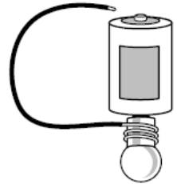 b. 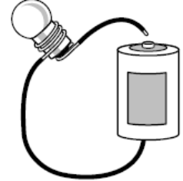 c. 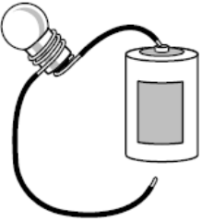 d. 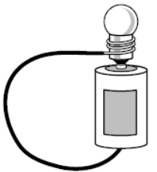

29. Which of these correctly shows how a light ray is reflected from a mirror?
a. 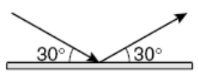 c. 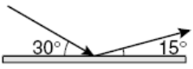
b. 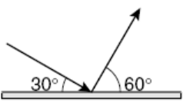 d. 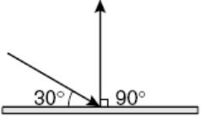

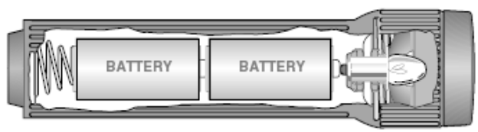
30. This flashlight uses three different forms of energy. Which of these shows the energy changes in the correct order?
a. mechanical → heat → chemical c. electrical → mechanical → chemical
b. heat → chemical → light d. chemical → electrical → light

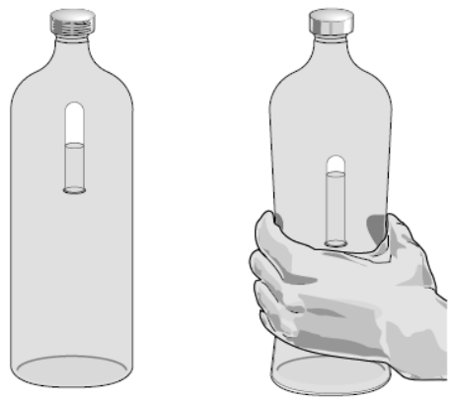
BEFORE AFTER
31. The picture shows a Cartesian diver made from a plastic bottle filled with water and an inverted tube partially filled
with water. What causes the diver to sink as the bottle is squeezed?
a. the size of the diver increases c. the water in the bottle comes less dense
b. the volume of air in the diver decreases d. the air in the water comes out of solution

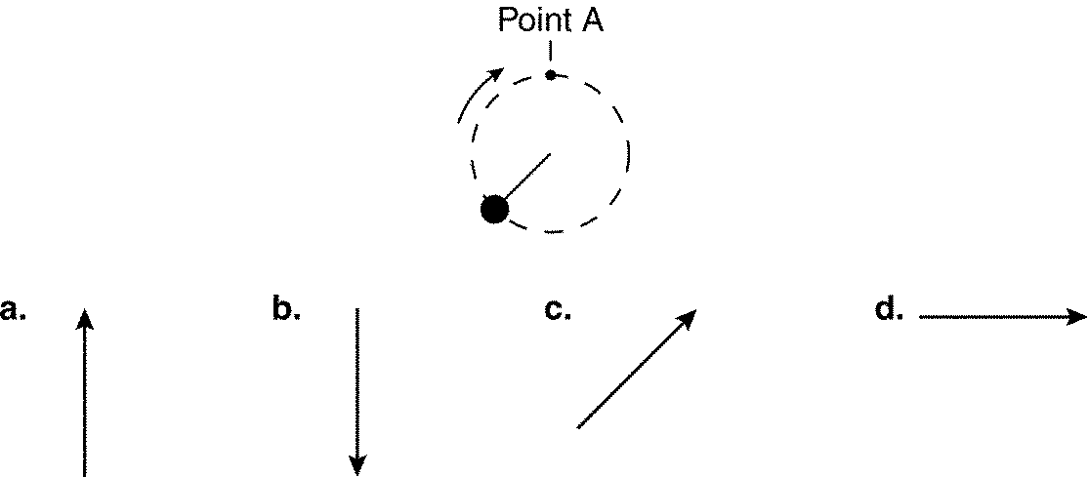
Figure 3-1

32. A ball attached to a string is being swung in a clockwise circular path as shown in Figure 3-1. Assume the string
breaks at point A. In which direction will the ball be traveling an instant later?
a. | direction a | c. | direction c
b. | direction b | d. | direction d

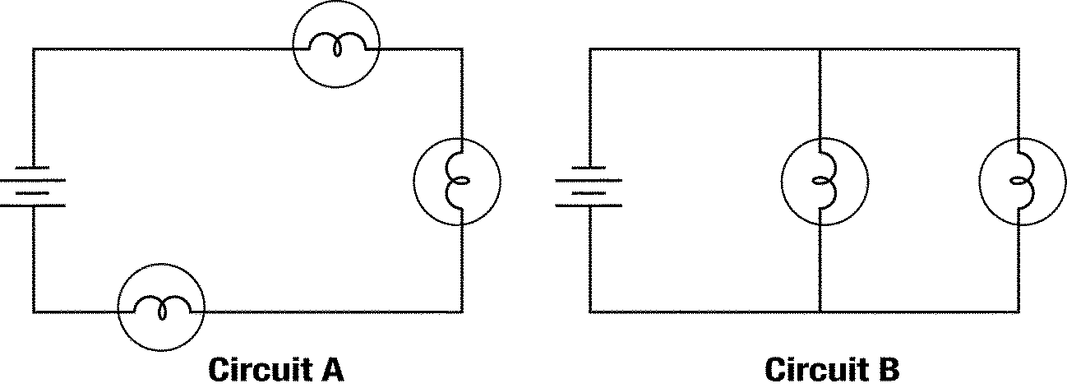
Figure 7-1

33. In Figure 7-1, circuit ____________________ is wired in series.

34. In Figure 7-1, circuit ____________________ is wired in parallel.

35. In Figure 7-1, circuit ____________________ represents the way that homes are usually wired.

36. In Figure 7-1, circuit ____________________ is the type of circuit that causes an entire string of decorative lights to
go out when one of the bulbs burns out.

Object | Mass | Velocity | Momentum
1 | 10 kg | 25 m/s | A.
2 | B. | 25 m/s | 300 kg  m/s
3 | 25 kg | C. | 300 kg  m/s
4 | D. | 25 m/s | 300 kg  m/s
Table 3-1

37. Complete Table 3-1 by calculating the missing values.

38. Which object in Table 3-1 has the greatest momentum?

39. Which object in Table 3-1 has the least momentum?

40. In Table 3-1, how does the momentum of object 2 compare with the momentum of object 3?

41. In Table 3-1, why is object 2's momentum greater than object 1's momentum?

42. In Table 3-1, what factor causes object 4 to have a greater momentum than object 3?

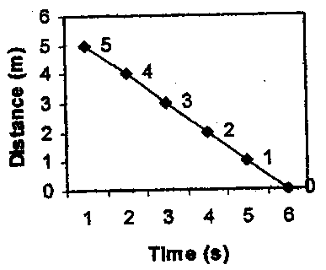

43. The position-time graph above shows
a. positive constant velocity c. an object at rest
b. negative constant velocity d. an object in free fall

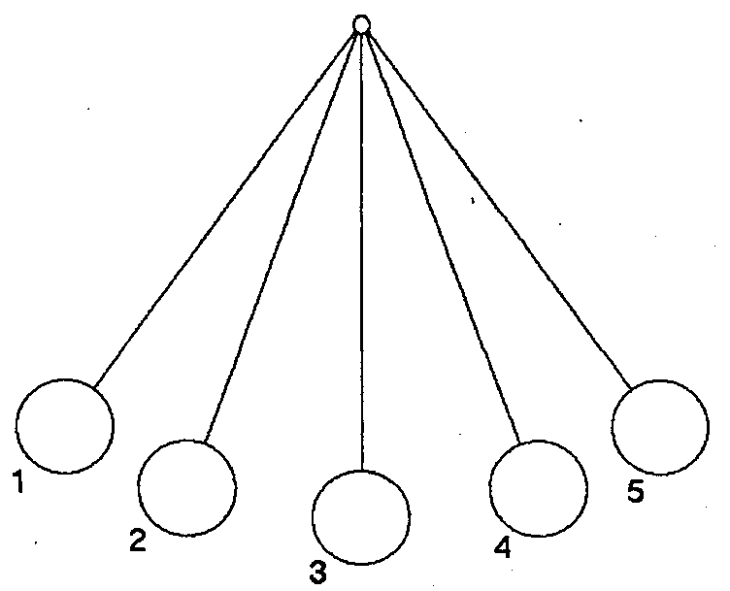

44. Refer to the pendulum above. At which point(s) does a pendulum have zero gravitational potential energy and
maximum kinetic energy?
a. points 1, 3, 5 c. points 2, 4 e. points 1, 2, 3, 4, 5
b. point 3 d. points 1, 5

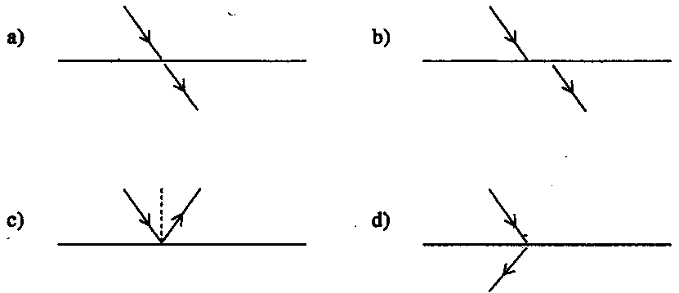
45. Which drawing illustrates the law of reflection?

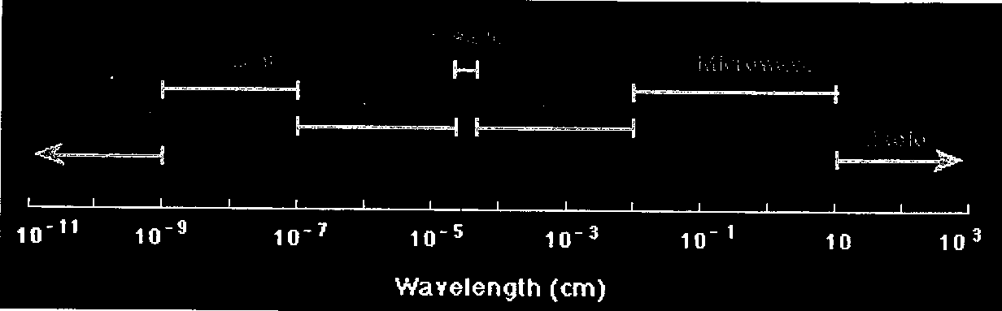

46. Which of the following would have the greatest frequency?
a. radio waves c. ultraviolet waves
b. infrared waves d. visible light

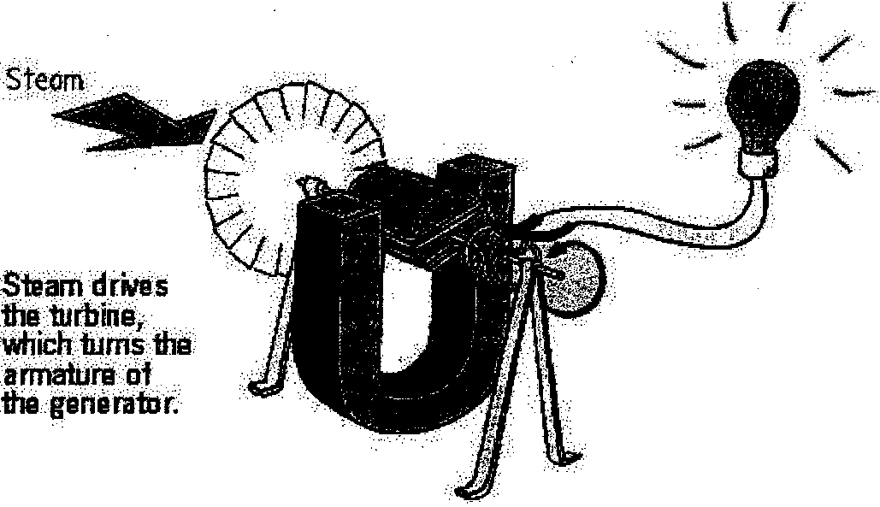

47. This structure produces power for use in the home by converting
a. chemical energy into mechanical energy c. chemical energy into electrical energy
b. electrical energy into mechanical energy d. mechanical energy into electrical energy
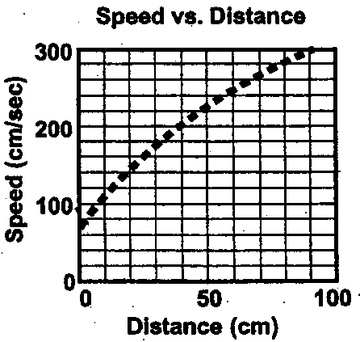
48. Use the graph to predict the speed when the car is at 60 cm.

a. 220 cm/sec c. 240 cm/sec
b. 230 cm/sec d. 250 cm/sec

49. In this speed vs. time graph, the object at point C:
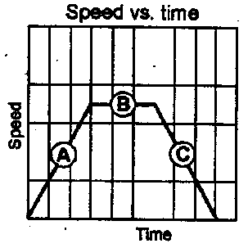

a. has positive acceleration c. has negative acceleration
b. has zero acceleration d. is moving at constant speed

50. A marble rolls along the track below with no friction. The sequence of positions on the track listed in order from the
lowest kinetic energy to highest kinetic energy is:
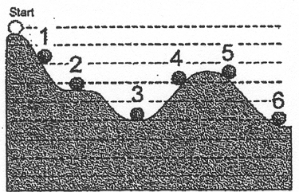

a. 1, 5, 4, 3, 6, 2 c. 1, 5, 4, 2, 3, 6
b. 1, 2, 3, 4, 5, 6 d. none of the above

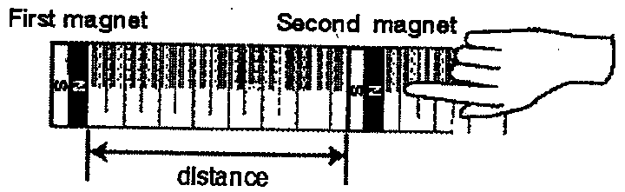

51. A student places two magnets with their north poles facing each other, about 70.0 cm apart. When he moves one magnet toward the other, the first magnet repels the second at a distance of 26 cm. He repeats the procedure, but now places the magnets so the south pole of one faces the north pole of the other. What is he likely to observe?
a. The first magnet will again repel the second at a distance of 26 cm.
b. The first magnet will attract the second at a distance of 26 cm.
c. The first magnet will repel the second at a distance of 52 cm.
d. The first magnet will attract the second at a distance of 52 cm.

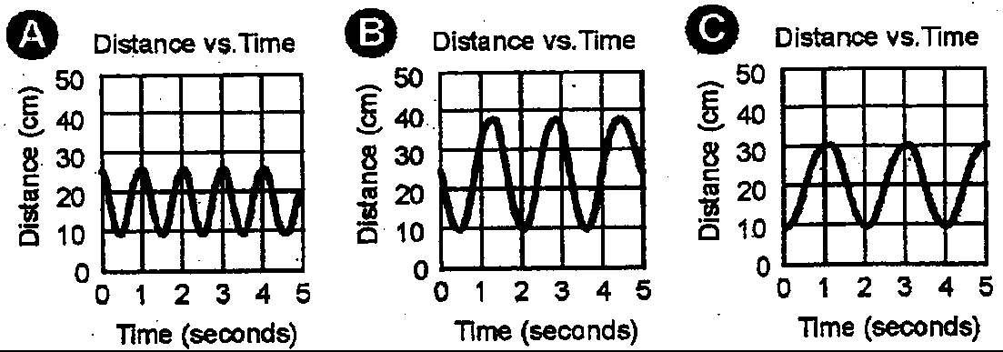

52. Which of the graphs in the figure above has an amplitude of 10 centimeters?
a. graph A c. graph C
b. graph B d. graphs B and C

53. Each figure below shows a force measured in newtons pushing on a block. If there are no other forces pushing on the
block, in which case is the acceleration of the block greatest?


