PHYS 321 S2022 X-ray Hwk1 Name:_____________________________
Rydberg Constant = R = 1.097 x 10⁷ m⁻¹, Speed of light = c = 3.0 x 10⁸ m/s.
Planck’s constant = h = 6.63 x 10⁻³⁴J.s
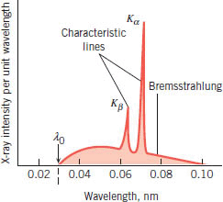

1.Explain the origin of the (a) Bremsstrahlung and (b) Characteristic
lines of the x-ray spectrum.

2. The voltage across an X-ray tube is 45 kV. The tin (Z = 50) is the target in the X-ray tube. Determine (a) the tube's cutoff wavelength (b) the wavelength of the K_{α} and L_{β} - ray lines emitted by the tin target.

3. Compute the frequency of the L_{α} x-ray line for the element with Z=73, Tantalum and compare it with Moseley’s data.
