PHYS 321 Problems on X-ray Diffraction Name:______________________________
- For the cubic system, derive expressions for the interplanar spacings for (100), (200), (110), and (111) planes and show that they agree with what is given by the following equation:
$d_{hkl}=\frac{a}{\sqrt{h^{2}+k^{2}+l^{2}}}$
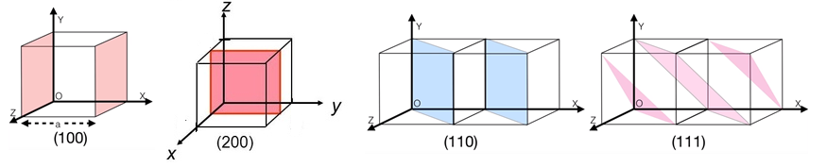

- The first order diffraction pattern for polycrystalline BCC iron with X-rays of wavelength 0.1790 nm is taken. Compute (a) the interplanar spacing and (b) the diffraction angle for the (220) set of planes. The lattice parameter for Fe is 0.2866 nm.

- The metal iridium has an FCC crystal structure. If the angle of diffraction for the (220) set of planes occurs at 69.22° (first-order reflection) when monochromatic x-radiation having a wavelength of 0.1542 nm is used, compute (a) the interplanar spacing for this set of planes, and (b) the atomic radius for an iridium atom.

- P3.64: Figure below shows an x-ray diffraction pattern for α-iron taken using a diffractometer and monochromatic x-radiation having a wavelength of 0.1542 nm; each diffraction peak on the pattern has been indexed (angles: 45⁰, 65⁰, and 83⁰. Compute the interplanar spacing for each set of planes indexed; also determine the lattice parameter of Fe for each of the peaks.
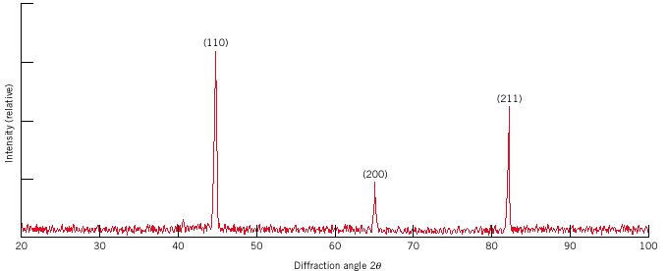

5. P3.66: Figure below shows the first four peaks of the x-ray diffraction pattern for copper, which has an FCC crystal structure; monochromatic x-radiation having a wavelength of 0.1542 nm was used.
(a) Index (i.e., give h, k, and l indices) for each of these peaks (angles: 43.8⁰, 50.8⁰, 74.4⁰, and 90.4⁰ .
(b) Determine the interplanar spacing for each of the peaks.
(c) For each peak, determine the atomic radius for Cu and compare these with the value presented in Table 3.1.
