PHYS 321 F 2016 Test #1 Name:________________________

A. The net potential energy between two adjacent ions, EN, may be represented by:



Calculate the equilibrium inter-ionic spacing, r0 and the bonding energy E0 in terms of the parameters A, B, and n.

B. Compute the percent ionic character of the inter-atomic bonds for the following compounds: MgO and GaAs. The electronegativity values are given below.  
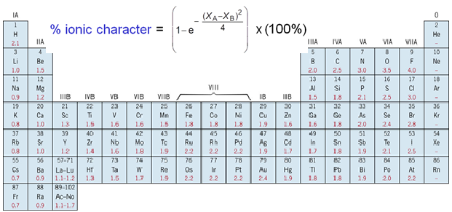

1. The unit cell for the face-centered cubic crystal structure is shown below.

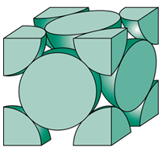

1. Show that the cube edge length, *a* and the atomic radius, R are   
related by:

2. Show that the atomic packing factor is 0.74 for FCC.

3a. Calculate the atomic radius of a lead atom, given that Pb has a FCC crystal structure, a density of 11.35 g/cm3, and an atomic weight of 207.2 g/mol.

3b. Calculate the planar density for (110) planes in lead.

D. Determine the density of CaTiO2. Ionic radius: Ca = 0.100 nm, O = 0.140 nm, and Ti = 0.068 nm. Atomic masses: Ca = 40.08, O = 16, Ti = 47.87

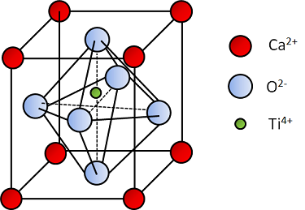

E. What are the indices for the directions shown, A and B within a cubic unit cell?

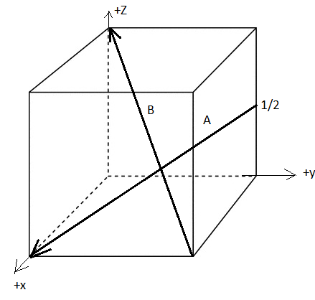

F. Determine the 3-axis indices and then convert them to 4-axis indices for the directions shown.







'

*w*

*w*

*t*

*v*

*u*

)

*v*

*u*

(

+

-

)

'

*u*

'

*v*

2

(

3

1

-

)

'

*v*

'

*u*

2

(

3

1

-



]

*uvtw*

[

]

'

*w*

'

*v*

'

*u*

[

→

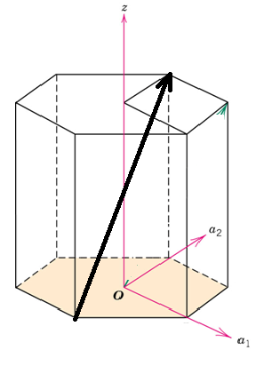

G. What are the Miller indices for the planes shown below?   
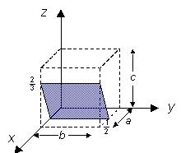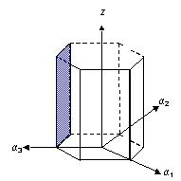

H. X-ray Diffraction:



Bragg=s law:

Additional Conditions: BCC: *h+k+l*=even FCC: h,k,l either odd or even

1. Figure below shows the first four peaks of the first order x-ray diffraction pattern for Cu2O [nanoparticles](javascript:popupOBO('CHEBI:50803','c1ra00261a')), which has an FCC crystal structure; monochromatic x-radiation having a wavelength of 0.1542 nm was used.

(a)Index (i.e., give h, k, and l indices) for each of these peaks, inside the parenthesis.

(b)Determine the interplanar spacing for each of the peaks.

(c)For each peak, determine the lattice constant, *a*.

(d) Use the average value of a, to calculate the diffraction angle for the next peak.

