PHYS 321 Simple-Cubic crystal structure Name:________________________
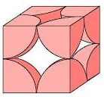
0. Metal: Po (Polonium)

1. How many atoms are inside the simple cubic unit cell?

2. Show the cube edge length, a and the atomic radius, R in
the figure.

3. How are the cube edge length, a and the atomic radius, R are related for a simple cubic structure?

4. Calculate the density of polonium, Po, which has a simple cubic crystal structure. Its atomic radius = 0.168 nm and atomic weight = 208.98 g/mol. (Avagadro’s number = 6.022 x 10²³) [http://www.ptable.com/]

