PHYS 321 Name:________________________________

1. The drawing shows sodium and chlorine ions positioned at the corners of a cube that is part of the crystal structure of sodium chloride (common table salt). The edge of the cube is 0.281nm (1nm=1 nanometer=10^{–9}m) in length.
a. Find the distance (in nanometers) between the sodium ion located at one corner of the cube and the chlorine ion located on the diagonal at the opposite corner.
b. What is the value of the angle θ in the above drawing?

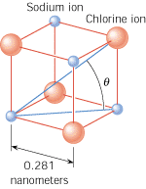

2. Iron (molar mass= 55.845 g/mol) has a density of 7.87 g/cm³. If the atoms are spherical and tightly packed, (a) what is the volume of an iron atom and (b) what is the distance between the centers of adjacent atoms?

