PHYS 321 Problems on Miller indices for planes in a cubic unit cell
3.41 Determine the Miller indices for the planes shown in the following unit cell:
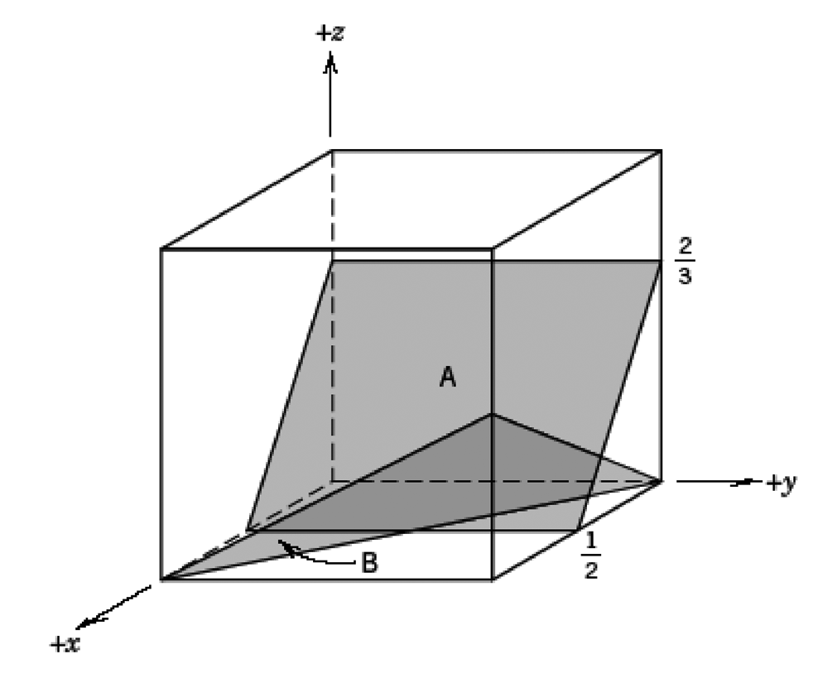
3.42 Determine the Miller indices for the planes shown in the following unit cell:
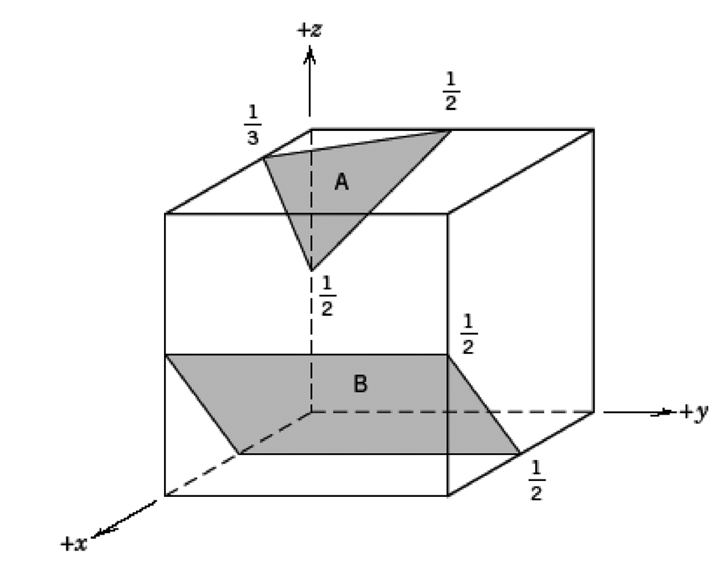
3.43 Determine the Miller indices for the planes shown in the following unit cell:
