PHYS 321 HW on Directions Name:________________________

3.29 *What are the indices for the directions indicated by the two vectors in the sketch below?*

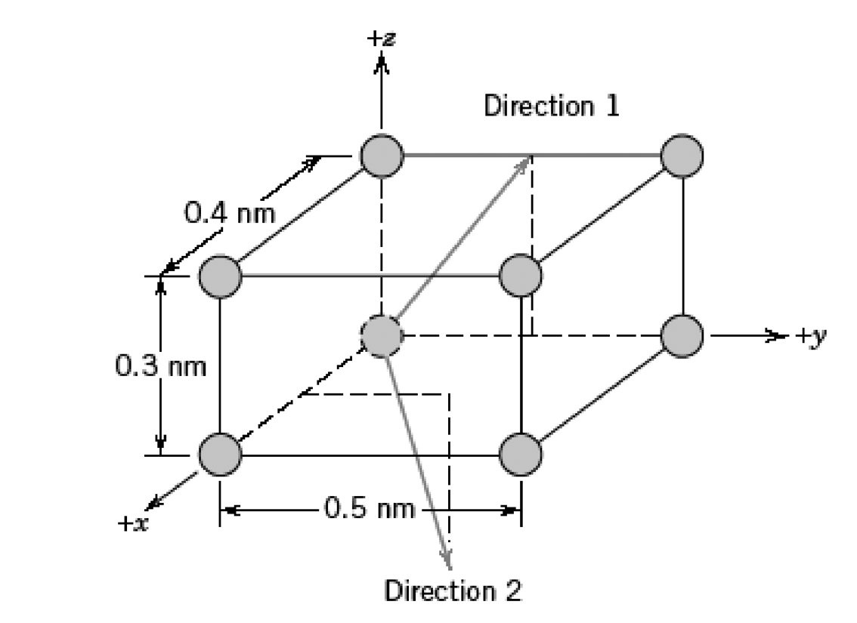

3.31  *Determine the indices for the directions shown in the following cubic unit cell:*

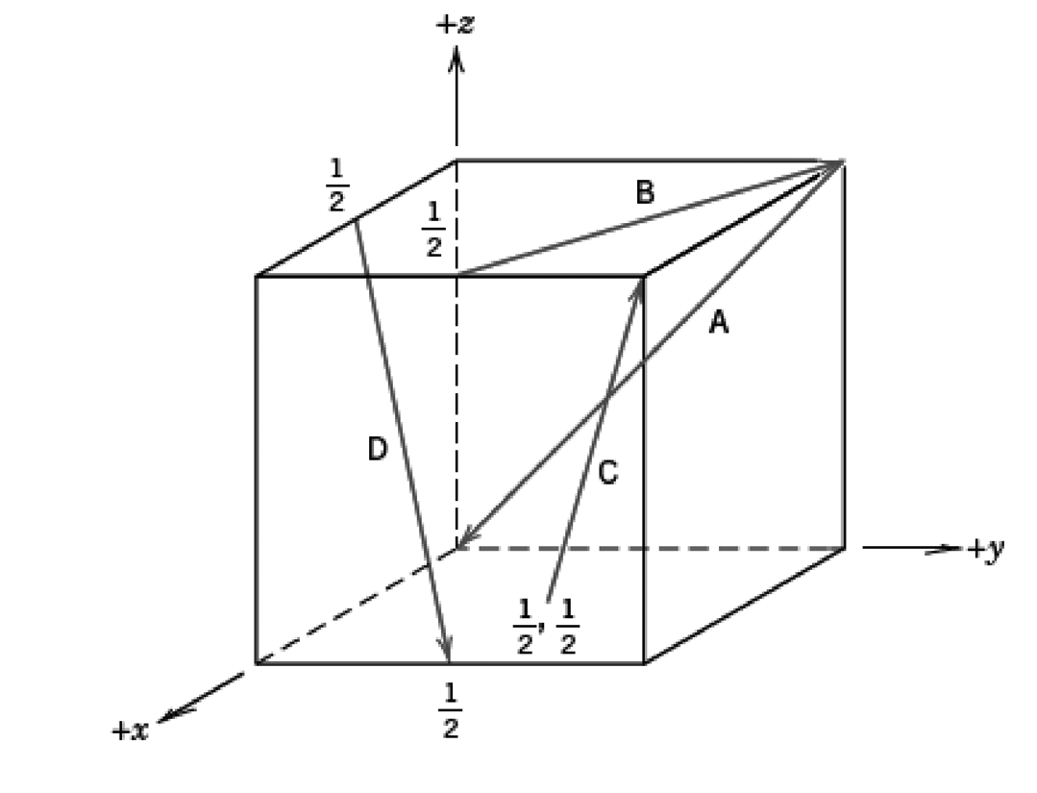

3.30 *Within a cubic unit cell, sketch the following directions:*

*(a)*, *(e)* ,

*(b)*, *(f)* ,

*(c)*, *(g)* ,

*(d)*, *(h)* .

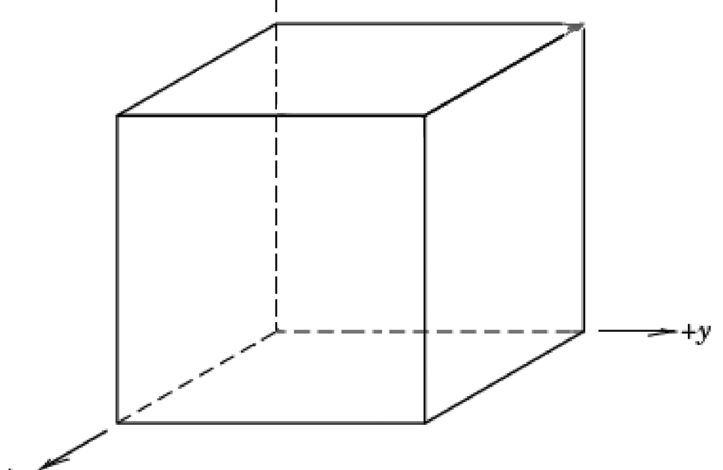

3.35. Determine the 3-axis indices and then convert them to 4-axis indices for the directions shown.

|  |  |
| --- | --- |
|  |  |

3.36 *Sketch the ,* [11 $\overline{2}$ 0], and * directions in a hexagonal unit cell.*

