PHYS 321 Materials Science Metallic Crystal Structures

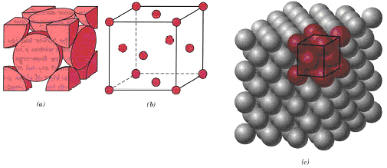
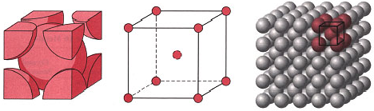

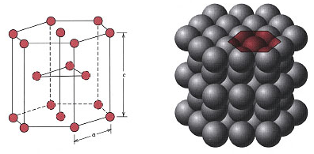

 | FCC | BCC | HCP
Coordination Number

Number of atoms per unit cell

Atomic Packing Factor

Atomic radius, R and unit cell edge, a are related by:
Metals

