PHYS 321 S 2014 HW-5 Name:________________________

- The unit cell for the body-centered cubic crystal structure is shown below.
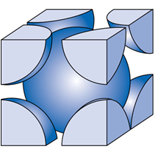
1. Show that the cube edge length, a and the atomic radius, R are
related by: $a=\frac{4R}{\sqrt{3}}$

2. Show that the atomic packing factor is 0.68 for BCC.

3a. Calculate the atomic radius of a vanadium atom, given that V has a BCC crystal structure, a density of 5.96 g/cm³, and an atomic weight of 50.9 g/mol.

3b. Calculate the planar density for (110) planes in vanadium.

