PHYS 32 Chap-2 Hwk-2 Name:____________________
$$\% Ionic Character=\left[1-e^{-0.25{\left(X_{A}-X_{B}\right)}^{2}}\right]x100$$
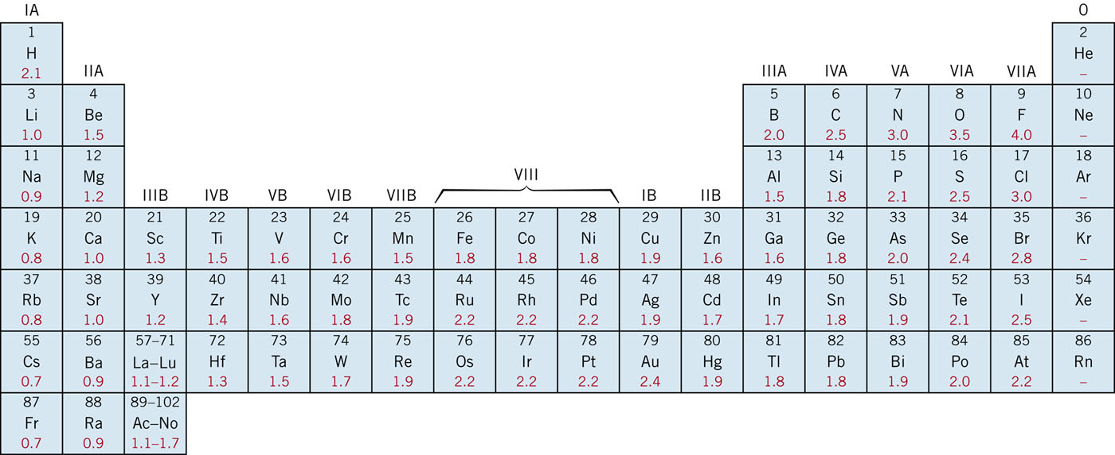

1. Generate a spreadsheet that computes %IC of a bond between atoms of two elements, when the user inputs values for the elements’ electronegativities.
2. Compute the percent ionic character of the inter-atomic bonds for the following compounds: ZnTe, CsCl, InSb, and MgCl₂. The electronegativity values are given above.

3. (a) Calculate %IC of the interatomic bonds for the intermetallic compound Al₆Mn.
(b) On the basis of this result, what type of interatomic bonding would you expect to be found in Al₆Mn?

4. Briefly cite the main differences among ionic, covalent, and metallic bonding.

5. Explain why hydrogen fluoride (HF) has a higher boiling temperature than hydrogen chloride (HCl) (19.4°C vs. −85°C), even though HF has a lower molecular weight.

