PHYS 321 Thermal Expansion Name:_____________________________





1. As a result of a temperature rise of 33 C°, a bar with a crac k at its center buckles upward as shown below. If the fixed distance *L*0 is 3.98 m and the coefficient of linear expansion of the bar is 25.0 × 10-6/C°, find the rise *x* of the center.

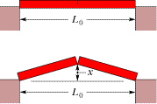

|  |  |  |  |
| --- | --- | --- | --- |
|  |  |  |  |
|  | | | |

2. Concrete sidewalks are always laid in sections, with gaps between each section. For example, the drawing shows three identical 2.4-m sections, the outer two of which are against immovable walls. The two identical gaps between the sections are provided so that thermal expansion will not create the thermal stress that could lead to cracks. What is the minimum gap width necessary to account for an increase in temperature of 32 C°?  
(α concrete = 12x10-6(Co)-1)

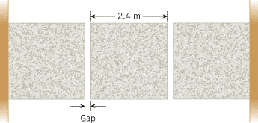

3. Suppose that the steel gas tank in your car is completely filled when the temperature is 17 °C. How many gallons will spill out of the twenty-gallon tank when the temperature rises to 35 °C? (α steel = 12x10-6(Co)-1, Volumetric coefficient of thermal expansion of gasoline = 950 x10-6(Co)-1)