PHYS 321 Heat Capacity Name:___________________________________

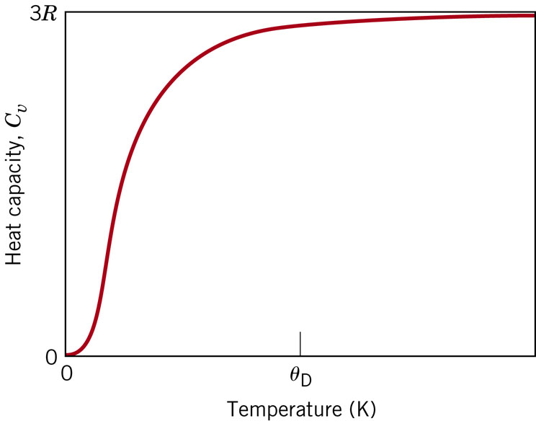

At low temperatures the relationship between *Cv* and the absolute temperature is

$C_{v}=AT^{3}$….. Eq. 19.2

19.1 Estimate the energy required to raise the temperature of 2 kg (4.42 lbm) of the following materials from 20 to 100°C (68 to 212°F): aluminum, steel, soda–lime glass, and high-density polyethylene. ($E=cm∆T$)

19.5 The constant A in Equation 19.2 is 12π4R/5, where R is the gas constant and θD is the Debye temperature (K). Estimate θD for copper, given that the specific heat is 0.78 J/kg-K at 10 K.