**PHYS 321 Name:_____________________**

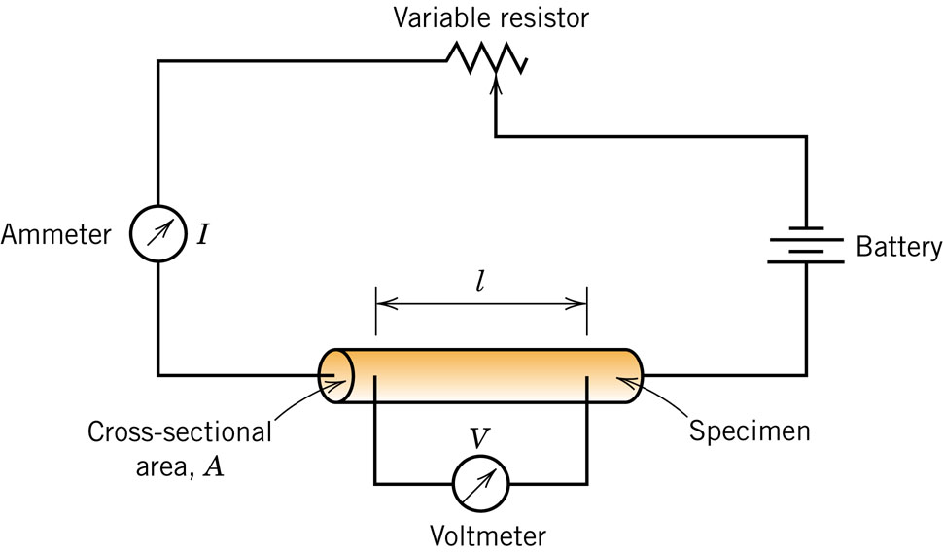

**Ohm’s Law and Conductivity:**

18.1 *(a)**Compute the electrical conductivity of a 5.1-mm   
(0.2-in.) diameter cylindrical silicon specimen 51 mm (2 in.)  
 long in which a current of 0.1 A passes in an axial direction.  
A voltage of 12.5 V is measured across two probes that   
are separated by 38 mm (1.5 in.).  
(b)**Compute the resistance over the entire 51 mm (2 in.)   
of the specimen.*

18.4 *Demonstrate that the two Ohm’s law expressions, V=IR and J=σE, are equivalent.*

**Electron Mobility: $σ=neμ$ $v_{d}=μE$**18.11 *At room temperature the electrical conductivity and the electron mobility for copper are 6.0 × 107 (-m)-1 and 0.0030 m2/V-s, respectively. (a) Compute the number of free electrons per cubic meter for copper at room temperature. (b) What is the number of free electrons per copper atom? Assume a density of 8.9 g/cm3.*

**Electrical Resistivity of Metals:**  
18.15 *Determine the electrical conductivity of a Cu-Ni alloy that has a yield strength of 125 MPa (18,000 psi). You will find Figure 7.16 helpful.*

