Name:_____________________________Date:_______________Time:____________
Partner(s):______________________________________Course:_________________
________________________________________________________________________
ac circuits lab A. Resistor and capacitor in an ac circuit:
Apparatus: ac adapter, capacitor box, resistor box, DMM, and wires.
1. Measure the output voltage of the ac adapter with the digital multimeter (DMM).
2. Connect a 10kΩ resistor, ammeter, and ac adapter in series as shown below. Calculate the current and also measure the current.
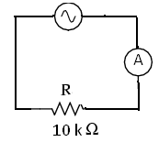
Output voltage of the ac adapter = V_{rms} =__________
Current, calculated = I_{rms} = _____________
Current, measured = I_{rms} = _____________
2. Connect a 0.5 µF capacitor, ammeter, and ac adapter in series as shown below. Calculate the reactance of the capacitor, then the current, and also measure the current.
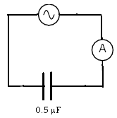
Output voltage of the ac adapter = V_{rms} =__________
Reactance of the capacitor = Χ_{C} = ______________
Current, calculated = I_{rms} = _____________
Current, measured = I_{rms} = _____________
2. Connect a 10 kΩ resistor, 0.5 µF capacitor, ammeter, and ac adapter in series as shown below. Calculate the reactance of the capacitor, then the current, and also measure the current.
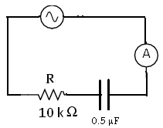
Output voltage of the ac adapter = V_{rms} =__________
Reactance of the capacitor = Χ_{C} = ______________
Current, calculated = I_{rms} = _____________
Current, measured = I_{rms} = _____________
Oscilloscope
A. Visit this signals website and answer the following questions:
1. Sketch V versus t graph of a DC signal, sine wave AC signal, and square wave AC signal below, inside the box.
DC signal | AC signal, sine wave | AC signal, square wave
------------------------------>t | ------------------------------>t | ------------------------------->t
2. Look at the four AC signals and find out a distinguishing feature of alternating waves.
_____________________________________________________________________
3. Sketch a V versus t graph of a sine wave AC signal and show the following in the wave: peak amplitude, peak-to-peak amplitude, and period.
---------------------------------------------------------------------->t

4. Define period and frequency of a wave:
Period:_________________________________________________________________
Frequency:______________________________________________________________
5. Write down the following equations:
a. Frequency in terms of period. _______________
b. rms amplitude in terms of peak amplitude._______________
6. Define rms amplitude:_________________________________________________
_______________________________________________________________________
B. Visit this oscilloscope website and answer the following questions:
1. What is the function of an oscilloscope?___________________________________
________________________________________________________________________
2. Look at the green screen of the oscilloscope and find the number of
a. vertical divisions ___________ b. horizontal divisions____________
3. When a signal is displayed on the screen, what is graphed on the
a. vertical axis ___________ b horizontal axis______________
4. Look at the VOLTS/DIV and TIME/DIV knobs and find out the following:
a. VOLTS/DIV: max _____ min_____ b. TIME/DIV: max _____ min_____
End of Web site activities--------------------------------------------------------------------------

Oscilloscope
Oscilloscope allows one to see signals, for example an ac signal.
1. An ac signal can be described with three properties; waveform, amplitude, and frequency. Instead of amplitude, peak-to-peak value or rms (root-mean-square) value can also be used. Meters read rms values. Can you describe the ac signal coming out of a wall-outlet in your home or in the laboratory? List the above three properties of the outlet signal below:
a. ___________________ b. ____________________ c. ______________________
2. For the waves shown below, determine peak-to-peak value, amplitude, period, and frequency.
Peak-to-peak value: Measure the vertical divisions from trough to crest and multiply it by the VOLTS/DIV setting. Peak value is half the peak-to-peak value.
Period: Measure the horizontal divisions from one crest (or trough) to the next and multiply it by the TIME/DIV setting.
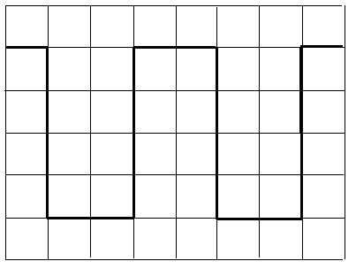 | 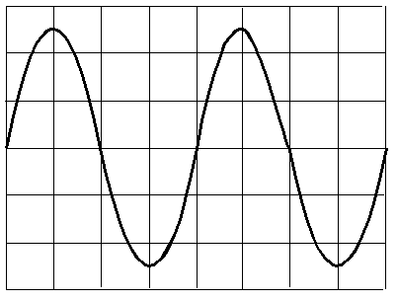
volt/div = 0.5V, time/div = 2 ms | volt/div = 2V, time/div = 1 µs
 | Sq. Wave | Sine Wave
1. The peak-to-peak amplitude of the signal
2. The peak amplitude of the signal
3. The period of the signal in second
4. The frequency of the signal in Hz

B. Purpose: To become familiar with the operation of an oscilloscope and to use it to investigate ac signals.
Apparatus: Oscilloscope, probe, function generator, digital multimeter (DMM), and an ac-adapter.
Theory: f = 1/T; peak amplitude = (peak-to-peak amplitude)/2, and rms amplitude = (peak amplitude)/1.414.
Calibration check of the oscilloscope:
- In the oscilloscope, set the input to GND (ground) and connect the scope-probe to the calibration signal of the scope.
- Turn on the scope, and you should see a horizontal trace, if you cannot see the horizontal trace call the instructor.
- Adjust the position controls and center the trace.
- Move the input from GND to AC, now you should see a square wave signal.
- Measure the peak-to-peak value and the period of the signal and complete the data table, B1.
AC-adapter:
- Write down the listed output voltage properties on the ac-adapter.
- Measure the output voltage with a digital multimeter.
- Connect the ac-adapter wires, white to red and black to black, to the oscilloscope probe and plug in the adapter. Measure the peak-to-peak value and the period of the signal and complete the data table, B2.
Function Generator:
- Connect the function generator wires to the scope-probe wires. (Red to Red and Black to Black).
- Set the frequency to 1000 Hz and select sine wave.
- Measure the peak-to-peak value, determine the amplitude, and complete the data table B3.
- Set the amplitude to max, measure the period, and complete the data table B4.

DATA
B1. Calibration check:
1. The peak-to-peak amplitude of the signal |  | Are your measured values match the values listed on the front of the scope?__________  (If not call the instructor)
2. The peak amplitude of the signal
3. The period of the signal in second
4. The frequency of the signal in Hz
B2. Signal from the ac-adapter:
Listed values: Output voltage = ____________ Frequency = ____________
Measured output voltage with a DMM = ______________________
1. The peak-to-peak value of the signal
2. The amplitude of the signal
3. The rms value of the signal
4. The period of the signal in second
5. The frequency of the signal in Hz
B3. Signal from the function generator:
Frequency = 1000 Hz, Sine wave Ampl = max
Measured output voltage with a DMM = ______________________
1. The peak-to-peak value of the signal
2. The amplitude of the signal
3. The rms value of the signal
4. The period of the signal in second
5. The frequency of the signal in Hz

B4. Change the frequency for constant amplitude. Amplitude = max, Sine wave.
Frequency from the function generator display (Hz) | From Scope Display Readings
 | Period | Period (sec) | Frequency (Hz)
100
1000
10,000
100,000
500,000
1000,000
C. Purpose: To measure the inductance (L) of an inductor coil using the resonance of R-L-C circuit.
Apparatus: Oscilloscope, probe, function generator, inductor coil, resistance box, capacitance box, and connecting wires.
Theory:
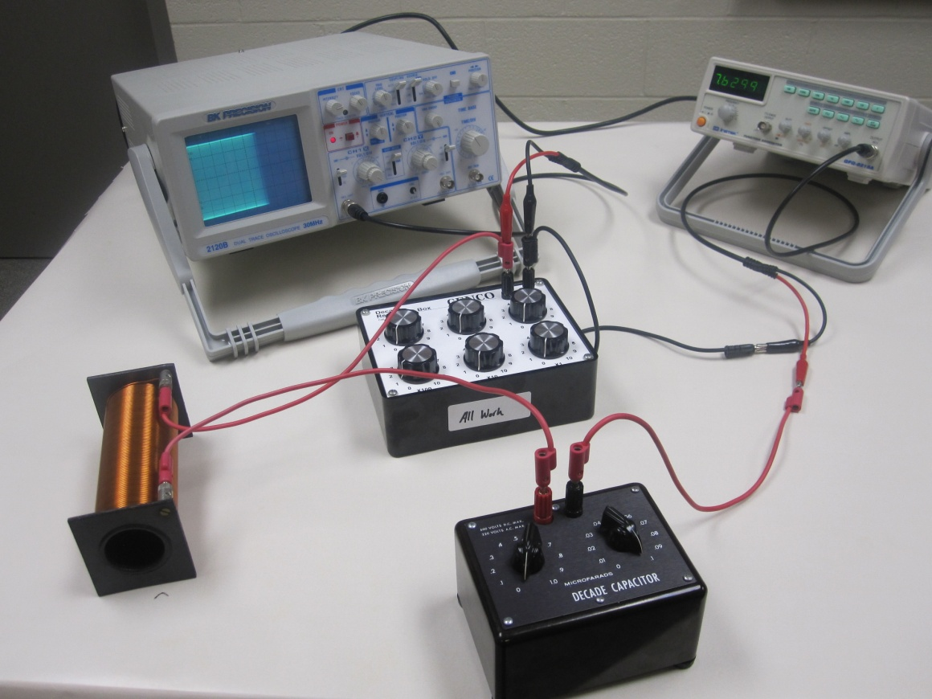
For a series R-L-C circuit, the resonance frequency (f) is given by, where L = inductance and C = capacitance; (Unit of inductance is Henry, H)
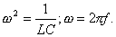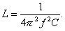
Procedure:
1. Set up the above circuit with R= 100 ohm, C = 0.1 µF, and Function Generator in sinewave, 10k, and max AMPL.
2. Vary the frequency until the signal in the scope display is a maximum. This will happen at the resonance.
3. Record the resonance frequency (f) from the function generator and calculate L.
4. Complete the data table.
Capacitance, C (µF) | Resonance frequency from function generator display, f (kHz) | Calculated inductance, L (H)
0.1
0.08
0.06
0.05
0.03
0.01
Average Inductance, L from Resonance
L from Digital Multimeter
% Difference
5. Keep C = 0.01 µF. Measure the peak-to-peak voltage across the resistance, V_{ptp} as a function of frequency, for 5 kHz, 10 kHz, 15 kHz, 20 kHz, 25 kHz, 30 kHz, 35 kHz, 40 kHz, 45 kHz, and 50 kHz. Tabulate your data and plot V_{ptp} versus f. Draw a smooth curve through the data points and see whether the resonance peak agrees with the data from Procedure-4 above. Attach your plot and write a conclusion.
________________________________________________________________________

