Name:_____________________________Date:_______________Time:____________
Partner(s):______________________________________Course:_________________
________________________________________________________________________
I. Pre-Lab on Oscilloscope:
A. Visit this signals website and answer the following questions:
1. Sketch V versus t graph of a DC signal, sine wave AC signal, and square wave AC signal below, inside the box.
DC signal | AC signal, sine wave | AC signal, square wave
------------------------------>t | ------------------------------>t | ------------------------------->t
2. Look at the four AC signals and find out a distinguishing feature of alternating waves.
_____________________________________________________________________
3. Sketch a V versus t graph of a sine wave AC signal and show the following in the wave: peak amplitude, peak-to-peak amplitude, and period.
---------------------------------------------------------------------->t
4. Define period and frequency of a wave:
Period:_________________________________________________________________
Frequency:______________________________________________________________

5. Write down the following equations:
a. Frequency in terms of period. _______________
b. rms amplitude in terms of peak amplitude._______________
6. Define rms amplitude (refer to the figure below):__________________________
________________________________________________________________________
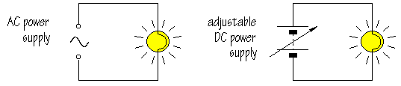
B. Visit this oscilloscope website and answer the following questions:
1. What is the function of an oscilloscope?___________________________________
________________________________________________________________________
2. Look at the green screen of the oscilloscope and find the number of
a. vertical divisions ___________ b. horizontal divisions____________
3. When a signal is displayed on the screen, what is graphed on the
a. vertical axis ___________ b horizontal axis______________
4. Look at the VOLTS/DIV and TIME/DIV knobs and find out the following:
a. VOLTS/DIV: max _____ min_____ b. TIME/DIV: max _____ min_____
C. Oscilloscope allows one to see signals, for example an ac signal:
1. An ac signal can be described with three properties; waveform, amplitude, and frequency. Instead of amplitude, peak-to-peak value or rms (root-mean-square) value can also be used. Meters read rms values. Can you describe the ac signal coming out of a wall-outlet in your home or in the laboratory? List the above three properties of the outlet signal below:
a. ___________________ b. ____________________ c. ______________________

2. For the waves shown below, determine peak-to-peak value, amplitude, period, and frequency.
Peak-to-peak value: Measure the vertical divisions from trough to crest and multiply it by the VOLTS/DIV setting. Peak value is half the peak-to-peak value.
Period: Measure the horizontal divisions from one crest (or trough) to the next and multiply it by the TIME/DIV setting.
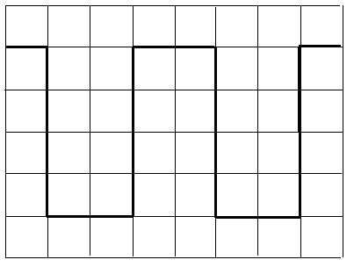 | 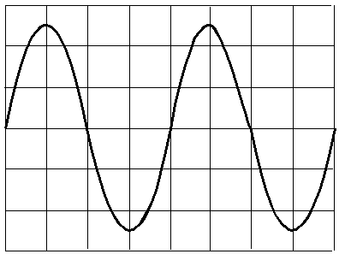
volt/div = 0.5V, time/div = 2 ms | volt/div = 2V, time/div = 1 µs
 | Sq. Wave | Sine Wave
1. The peak-to-peak amplitude of the signal
2. The peak amplitude of the signal
3. The period of the signal in second
4. The frequency of the signal in Hz
II. Purpose: To become familiar with the operation of an oscilloscope and to use it to investigate ac signals.
Apparatus: Oscilloscope, probe, function generator, digital multimeter (DMM), and an ac-adapter.
Theory: f = 1/T; peak amplitude = (peak-to-peak amplitude)/2, and rms amplitude = (peak amplitude)/1.414.
Calibration check of the oscilloscope:
- In the oscilloscope, set the input to GND (ground) and connect the scope-probe to the calibration signal of the scope.
- Turn on the scope, and you should see a horizontal trace, if you cannot see the horizontal trace call the instructor.
- Adjust the position controls and center the trace.
- Move the input from GND to AC, now you should see a square wave signal.
- Measure the peak-to-peak value and the period of the signal and complete the data table, B1.
AC-adapter:
- Write down the listed output voltage properties on the ac-adapter.
- Measure the output voltage with a digital multimeter.
- Connect the ac-adapter wires, white to red and black to black, to the oscilloscope probe and plug in the adapter. Measure the peak-to-peak value and the period of the signal and complete the data table, B2.
DATA
Calibration check:
1. The peak-to-peak amplitude of the signal |  | Are your measured values match the values listed on the front of the scope?__________  (If not call the instructor)
2. The peak amplitude of the signal
3. The period of the signal in second
4. The frequency of the signal in Hz

Signal from an ac-adapter:
Listed values: Output voltage = ____________________ Frequency = __________
Measured values with a DMM: Output voltage = _______Frequency = _______
1. The peak-to-peak value of the signal
2. The amplitude of the signal
3. The rms value of the signal
4. The period of the signal in second
5. The frequency of the signal in Hz

Diodes in Rectification: Breadboard, shown below, will be used to make the circuits.
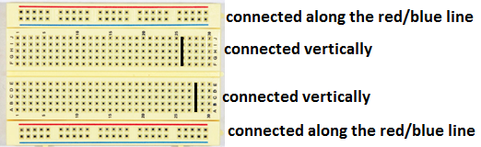

 | Expected Output across R | Output from Scope
Bridge Rectifier:

 | Expected Output across R | Output from Scope
Small capacitor across R
Large capacitor across R

