PHYS 315 HWK on Resistors Name:___________________________

a. Ohm’s law: V=IR; b. Power = P = IV= I2R = V2/R

c. When resistors (*R1*, *R2*, *R3*) are connected in series the equivalent resistance (*Rs*) is given by,



d. When resistors (*R1*, *R2*, *R3*) are connected in parallel the equivalent resistance (*Rp*) is given by,



1. Find the equivalent [resistance](javascript:parent.xlinkeyword('u0028')) between points *A* and *B* for the resistor network shown below. (Ans: 4.67 ohm)

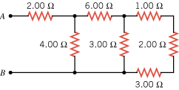

2. In Fig. [27-53](http://edugen.wiley.com/edugen/courses/crs4957/halliday9118/halliday9088c27/halliday9118/halliday9088c27/halliday9088c27xlinks.xform?id=halliday9088c27-fig-0053), *R*1 = 100 *Ω*, *R*2 = *R*3 = 50.0 *Ω*, *R*4 = 75.0 *Ω*, and the ideal battery has emf http://edugen.wiley.com/edugen/courses/crs4957/common/art/glyphs/isomscr/U02130.gif = 6.00 V. (a) What is the equivalent resistance? What is *i* in (b) resistance 1, (c) resistance 2, (d) resistance 3, and (e) resistance 4?

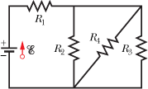

3. In Fig. [27-44](http://edugen.wiley.com/edugen/courses/crs4957/halliday9118/halliday9088c27/halliday9118/halliday9088c27/halliday9088c27xlinks.xform?id=halliday9088c27-fig-0044), the current in resistance 6 is *i*6 = 1.40 A, and the resistances are *R*1 = *R*2 = *R*3 = 2.00 *Ω*, *R*4 = 16.0 *Ω*, *R*5 = 8.00 *Ω*, and *R*6 = 4.00 *Ω*. What is the emf of the ideal battery?

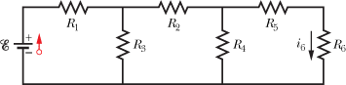

4. Figure [27-78](http://edugen.wiley.com/edugen/courses/crs4957/halliday9118/halliday9088c27/halliday9118/halliday9088c27/halliday9088c27xlinks.xform?id=halliday9088c27-fig-0078) shows a portion of a circuit through which there is a current *I* = 6.00 A. The resistances are *R*1 = *R*2 = 2.00*R*3 = 2.00*R*4 = 4.00 *Ω*. What is the current *i*1 through resistor 1?

|  |  |  |  |  |  |  |
| --- | --- | --- | --- | --- | --- | --- |
| pixel | |  | | --- | | pixel | | |  |  |  | | --- | --- | --- | | |  | | --- | | pixel | | nt0091-y | | | |

5. You are given a black box with three terminals, as shown below. The box is known to contain five 1-ohm resistors.

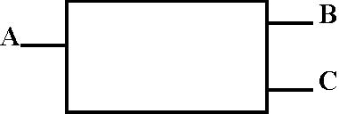

Using an ohm-meter, you measure the resistance between the terminals to be the following:   
A - B: 1.5 ohms B - C: 3 ohms A - C: 2.5 ohms  
Determine the configuration of the five resistors inside the box.