PHYS 315 Practice for Test #2 Name:______________________________

 http://edugen.wiley.com/edugen/courses/crs4957/halliday9118/halliday9088c25/image_n/nt0014-y.gif http://edugen.wiley.com/edugen/courses/crs4957/halliday9118/halliday9088c25/image_n/nt0016-y.gif

1) Find the equivalent capacitance between A and B. Also find the charge on 6µF capacitor.

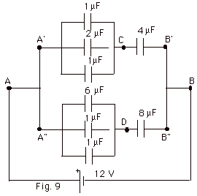

2. Reduce the following ckt into a Thevenin’s equivalent ckt between a and b:  
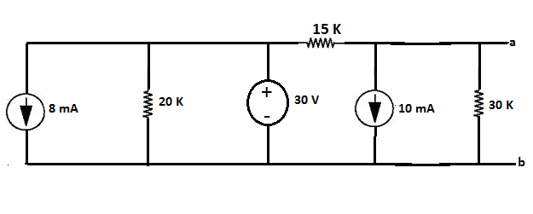

3. TRANSISTOR AMPLIFIER

1. Write down three good characteristics of an amplifier.
2. Name the type (common base, common emitter, or emitter follower) of amplifier shown below:____________________

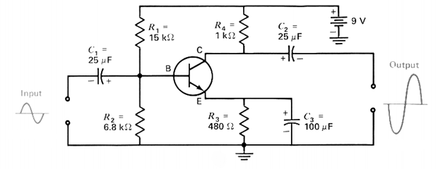

1. Calculate the following DC bias conditions: VB, VE, IE, IC, IB, VC, VCE, and the small signal gain.   
   (Assume that the transistor is a Si type, with β=150)

4. For the following op-amp, operating in ideal conditions, find the following:

a. Calculate *vo* when *vs* = 3.5 volt, peak sine wave.  
b. Specify the range of *vs* to avoid amplifier saturation.

