PHYS 315 Operational Amplifier Lab Name:___________________________
1. Apparatus: Heath kit Electronic design experimenter, digital multimeter, and oscilloscope.
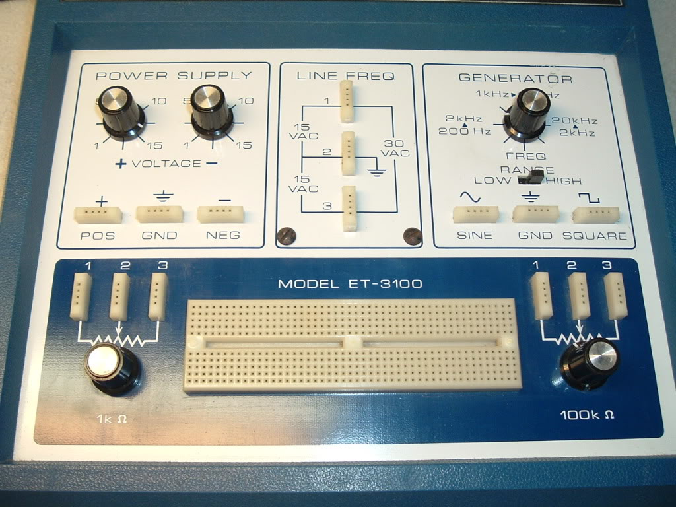
a. Setting up the bias voltages: Use a digital multi meter and set the + and – DC voltages to +10V and -10 V.
b. Setting up the input ac signal: Use the oscilloscope and set the input signal to 1000 Hz at about 0.2 v ptp, using the 100 KΩ potentiometer, as shown below.
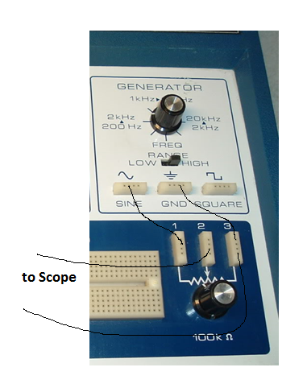

2. Identifying the 741 op-amp terminals:
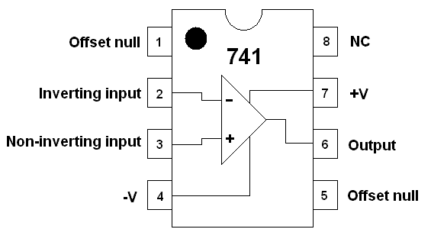

3. Inverting amplifier: Set up the circuit below, and complete the following data table.
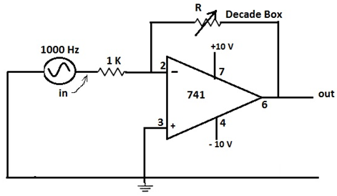
R (kΩ) | gain, a (calculated) | V in (ptp volt) | V out (ptp volt) | gain (measured)
5
10
15
20
4. Non-inverting amplifier: Set up the circuit below, and complete the following data table.
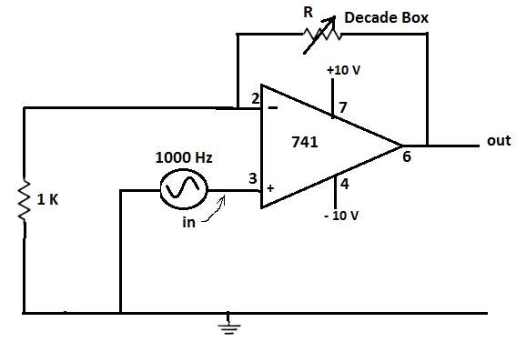
R (kΩ) | gain, a (calculated) | V in (ptp volt) | V out (ptp volt) | gain (measured)
5
10
15
20
5. Follower: Set up the following circuit and measure the gain.___________________
