PHYS 315 S2017 Practice for Test #2 Name:______________________________

 http://edugen.wiley.com/edugen/courses/crs4957/halliday9118/halliday9088c25/image_n/nt0014-y.gif http://edugen.wiley.com/edugen/courses/crs4957/halliday9118/halliday9088c25/image_n/nt0016-y.gif

1) Find the equivalent capacitance seen by the voltage source. Also find the charge on the 2 µF capacitor.

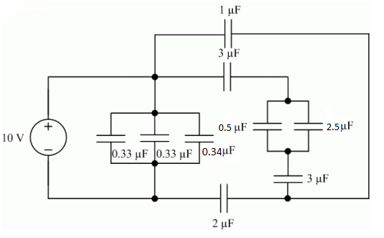

For the amplifier shown, calculate: VB1, VE1, IE1, IC1, VE2. (Assume β=100)

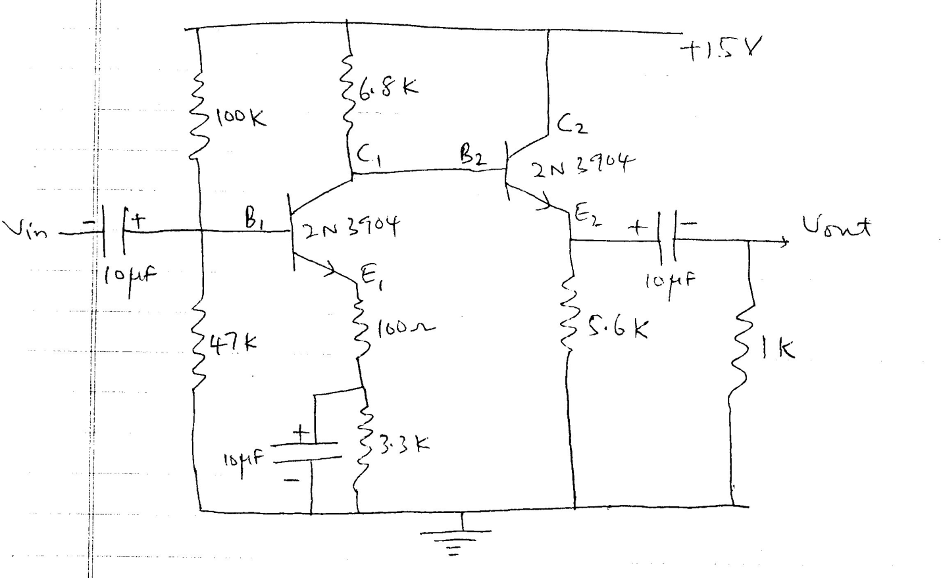

Watch this video for some basics on Op-Amp: <https://www.youtube.com/watch?v=2SwT6JnfCq8>

1. Find the gain for the following circuits:

|  |  |
| --- | --- |
| Inverting Amplifier Circuit.  Vin on the left connected to R1 connected to the negative terminal of the opamp connected to R2 connected to Vout and the output of the opamp.  Positive terminal of the opamp tied to ground. | Noninverting Amplifier circuit |
|  |  |

2. Calculate the output voltage if V1 = V2 = 0.15 V.

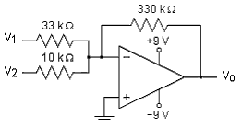

3. Calculate the output voltage if V1 = V2 = 700 mV.

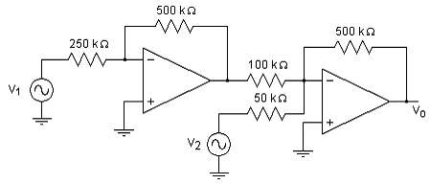

6.Calculate V0.

