PHYS 315 Op-amp Problems Name:______________________________

1. Calculate the output voltage, VO.

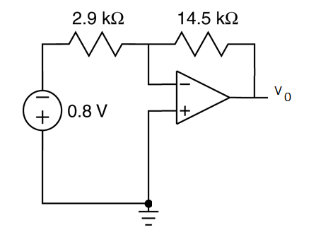

1. In the following circuit, if VO=-4.88 V, what is the value of R?

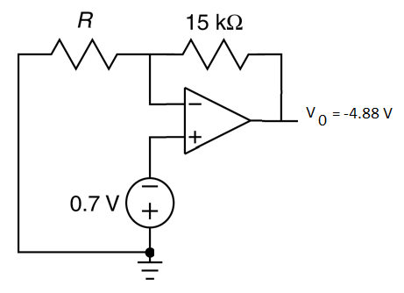

1. Consider the circuit shown in Figure 3. Find the value of voltage measured by the voltmeter. Determine the value of the power supplied by the op amp.



1. Calculate the output voltage, VO.

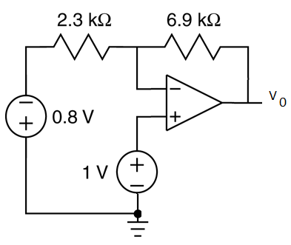

Calculate the output voltage, VO.

