I-V Characteristics
Purpose: To study the I-V characteristics of different circuit elements.
Apparatus: DC power supply, connecting wires-3 (red-2 and black-1), 2-alligator clips, 5-ohm resistor, 10-ohm resistor, light bulb, diode, voltage sensor, high-current sensor, and PASCO 850 interface w/Capstone.
Procedure:
- Turn on the power supply and turn down the voltage and current controls to zero.
- Set up the following circuit:
a. Plug-in the high-current sensor to the interface.
b. Connect the power supply, 5-ohm resistor, and the current sensor in series. (Keep track of the polarities: positive with positive and negative with negative).
c. Connect the voltage sensor across the 5-ohm resistor, and plug-in to the interface. 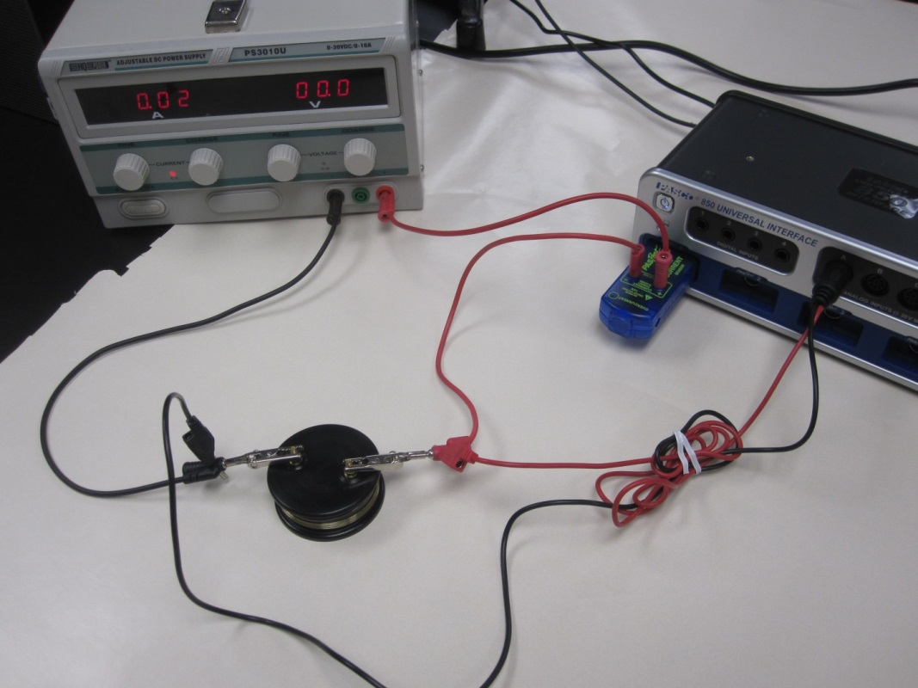
- Setting up the interface/PC for data collection using the Keep Mode:
a. Open PASCO Capstone software from the desktop.
b. Click Hardware Setup under Tools on the left.
c. Make sure that the Pasport current sensor is identified by the interface.
d. Click on the interface input where the voltage sensor is connected and select Voltage Sensor. Click Hardware Setup again to close it.
e. Click on “Continuous Mode” in the bottom, and select Keep Mode.
f. Click Table and Graph, click Select Measurement on the first column, and select Current. Click Select Measurement on the second column, and select Voltage. For the graph, choose current on the x-axis and voltage on the y-axis.
g. Click Preview.
- Increase the current to about 1A. Voltage will also increase. When the current and voltage are steady, Click Keep Sample to collect the first set of data. Collect more data by lowering the current by 0.1 A, until the current goes to zero.
- Reverse the connections to the power supply. Continue collecting data by lowering the current by 0.1A, until you reach a current of -1A.
- Stop the data collection, copy, and save your results as a word document.
- Repeat the measurements for a 10-ohm resistor, and save your results.
- Repeat the measurements for a light bulb for the following conditions:
Maximum current = 0.3 A, collect data by lowering current by 0.05 A till about 0.1 A, then by lowering 0.02 A, until the current goes to zero, and for negative values.
- Save your results.
- Repeat the measurements for a diode for the following conditions:
For the graph, choose Voltage on the x-axis and Current on the y-axis.
Maximum current = 2.0 A, collect data by lowering current by 0.2 A till about 0.2 A, then by lowering 0.02 A, and for negative values. Save your results.
