PHYS 301 Measuring e/k Name:_________________________________
Apparatus: PNP transistor, proto-board, 2-digital-multimeters (A and V), rheostat, D-cell battery w/holder, 3 proto-board wires, 5 alligator clips, 3 red banana plug wires, and 4 black banana plug wires.
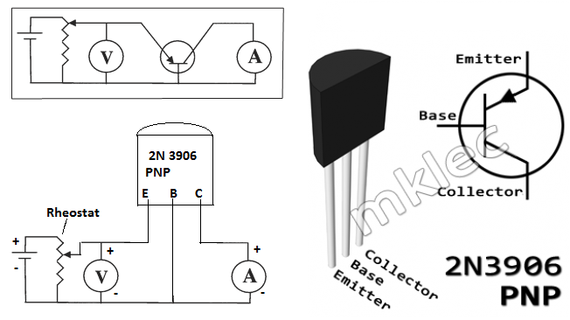
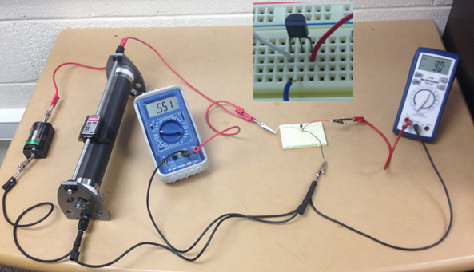

1. Set up the above circuit. V: 2V DC, A: DC µA. Slide down the rheostat until the ammeter reads a low current, in the range of 5-10 µA. Record the current, I and voltage, V.
2. Slide up the rheostat to increase the current to about 30 µA, and collect data. Collect more data by increasing the current, until the current reaches about 500 µA.
3. Tabulate the data, plot an appropriate graph, and obtain e/k.
I (µA) | V (volt) | LN (I)

