PHYS 301 Name:_____________________________
Wave function for a particle in a 1D infinite potential well:
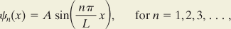
Sketch the wave function and probability for a particle in a 1D infinite potential well, below.
