PHYS 301 Name:_____________________________
Probability in a 1D infinite potential well
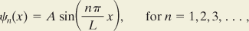
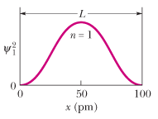
A ground-state electron is trapped in the one-dimensional infinite potential well with width L = 100 pm.
a. What is the probability that the electron can be detected in the left one-third of the well (x₁ = 0 to x₂ = L/3)?
b. What is the probability that the electron can be detected in the right one-third of the well (x₁ = 2L/3 to x₂ = L)?
c. What is the probability that the electron can be detected in the middle one-third of the well?

