PHYS 256 Wave form and Fourier Spectrum Name:__________________________
Wave form and Fourier spectrum of a note played on a violin are shown below.
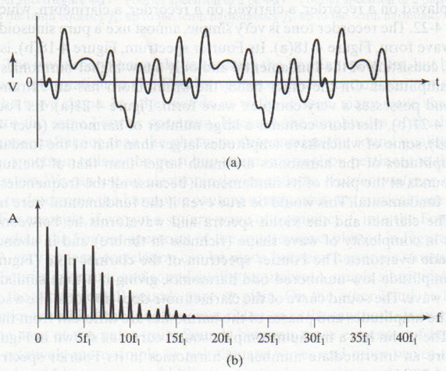
- Show the period in the waveform.
- If the fundamental frequency is 500 HZ, calculate the period.

- What is the frequency of the harmonic with the highest frequency?

- Write down the frequencies of the four high-amplitude harmonics in decreasing order of amplitude.

- How is the amplitude of the 7th harmonic related to the amplitude of the fundamental?

- Which harmonics have the same amplitude?

