PHYS Lab Wave Phenomena Data Name:____________________  
Partner(s):_____________________________________________________

1. Go to the following website and select the simulation “Interference of light” under Chapter 36.  
   <http://bcs.wiley.com/he-bcs/Books?action=mininav&bcsId=5586&itemId=0470469080&assetId=211452&resourceId=20409&newwindow=true>
2. Listen to the audio introduction.
3. Write down the wavelength and Single Slit properties:   
   Wavelength =_______________Slit Width = ___________Slit-Screen dist.=___________
4. Sketch the intensity curve shown for the single slit below.
5. Describe what happens to the single-slit pattern as you change the following:  
   1. Wavelength:

2. Slit-width:  
  
3. Slit to screen distance:

Select double-slit and do the following: Wavelength =___________  
Slit Width = _________Slit-Screen dist.=________Slit-Separation =___________  
Sketch the intensity curve for a double slit below:

1. Describe what happens to the double-slit pattern as you change the following:  
   1. Wavelength:

2. Slit-width:  
  
3. Slit to screen distance:  
   
4. Slit-Separation:

Purpose: Determine the wavelength of light using wave phenomena.

A. Diffraction Grating

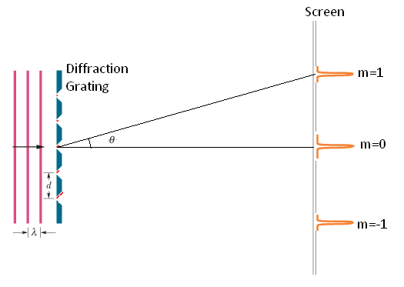

http://edugen.wiley.com/edugen/courses/crs4957/halliday9118/halliday9088c36/image_n/nt0060-y.gif

Determine the wavelength of the laser light by measuring the appropriate quantities. Write down every data you collect and show your work below. Also calculate your %error. Assume that there 500 lines/mm in the given grating.  
   
________________________________________________________________________  
  
________________________________________________________________________  
  
________________________________________________________________________   
  
________________________________________________________________________

________________________________________________________________________

B. Double-Slit Interference

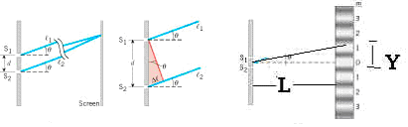

Number of fringes = N = _________

Width for the above number of fringes = _______________________

Fringe-width = Y = __________

Double-Slit separation = d = _________

Double-Slit to Screen distance = L = __________

Wavelength (measured) = λ = dY/L = __________

Wavelength (accepted) = λ = ___________

                            % Error = ____________

C. Single-Slit Diffraction

|  |  |
| --- | --- |
| F27.23 | F27.24 |



Width for the central bright fringe = 2Y =  _______________________________

Half-width for the central bright fringe = Y = ________

Single-Slit width = a = w = _________

Single-Slit to Screen distance = L = __________

Wavelength (measured) = λ = wY/L = __________

Wavelength (accepted) = λ = ___________

                            % Error = ____________

Conclusion for wave phenomena: