PHYS Lab on Spectra Name:______________________
A. Pre-Lab:
1. Expain the origin of light? https://www.youtube.com/watch?v=7BFM46vJbrI

2. Energy levels of the electron of the hydrogen atom are shown below. Calculate and list the energy values, $E_{n}=-\frac{13.6}{n^{2}}$eV, with the orbitals.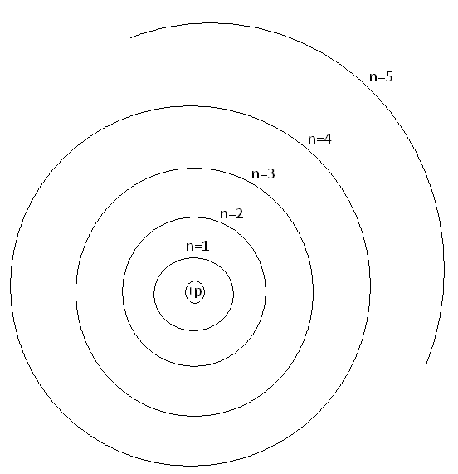
3. Show the transitions of electron for the Lyman (1), Balmer (2), and Paschen (3) series in the above diagram.
4. Calculate the 4 of the highest wavelengths (λ) of the Balmer series.
$∆E=\frac{hc}{λ}$; h = 6.63x10⁻³⁴J.s and c = 3x10⁸m/s. 1eV=1.6x10⁻¹⁹J

B. Visit this Bohr Atom website and answer the following questions:
1. What is a Bohr atom?______________________________________________
2. What do the numbers next to the buttons on the right mark?
_________________________________________________________________
3. How are the electron orbits shown?____________________________________
4. Wavelength range in nm of the visible spectrum: 400 nm ----700 nm.
5. To find out the transitions to which electron orbit will result in the visible spectra (Balmer series):
a. Select the first button. | Click on the second electron orbit and observe the wavelength of the line emitted.  Is this a visible line?_______  Click on the third electron orbit and observe the wavelength of the line emitted.  Is this a visible line? _______  Click on the fourth electron orbit and observe the wavelength of the line emitted.  Is this a visible line? _______  Click on the fifth electron orbit and observe the wavelength of the line emitted.  Is this a visible line? ________  Click on the sixth electron orbit and observe the wavelength of the line emitted.  Is this a visible line? _________  Click on the seventh electron orbit and observe the wavelength of the line emitted.  Is this a visible line? ________  Click on the eight electron orbit and observe the wavelength of the line emitted.  Is this a visible line? _________
b. Select the second button. | Click on the third electron orbit and observe the wavelength of the line emitted.  Is this a visible line? ________  Click on the fourth electron orbit and observe the wavelength of the line emitted.  Is this a visible line? ________  Click on the fifth electron orbit and observe the wavelength of the line emitted.  Is this a visible line? ________  Click on the sixth electron orbit and observe the wavelength of the line emitted.  Is this a visible line? ________  Click on the seventh electron orbit and observe the wavelength of the line emitted.  Is this a visible line? ________
c. Select the third button. | Click on the fourth electron orbit and observe the wavelength of the line emitted.  Is this a visible line? ________  Click on the fifth electron orbit and observe the wavelength of the line emitted.  Is this a visible line? _________  Click on the sixth electron orbit and observe the wavelength of the line emitted.  Is this a visible line? ________  Click on the seventh electron orbit and observe the wavelength of the line emitted.  Is this a visible line? ________
6. Make sure that the second button is selected. Click on the third electron orbit. You will see the electron transition from third electron orbit to the second electron orbit resulting in a red line emission. Record the wavelength (λ) and change in energy (ΔE) in the data table. Repeat this for other electron orbits and complete the data table. You will complete the last three columns when you do the measurements with the Ocean Optics spectrometer.
Data for H-spectrum:
Transition from | ΔE | λ, from website | λ, measured | %Difference | Intensity Count
3rd electron orbit
4th electron orbit
5th electron orbit
6th electron orbit
7th electron orbit
7. Plot ΔE versus 1/λ, determine the slope with unit. Slope = ______________
Calculate a theoretical value for the slope in the same unit.
_______________________________________________________________________
8. Set up the fiber optic cable next to the hydrogen spectrum tube and turn on the tube.
9. Open the Ocean Optics program (OOIBase32, from desktop).
10. Click on the Toggle Cursor BUTTON (1st on right-top) to display the green vertical line (curser).
11. Click on a peak to move the cursor over the peak, use the arrow keys to align the cursor over the peak. Wavelength and intensity are read from the bottom-left corner.
12. Measure the wavelengths for the lines you observe. Record the measured values in the above data table, and calculate the %difference.
13. Adjust the position of the cable-head so that the intensity of the highest peak is close to the maximum count.
14. Click on the Global Snapshot button (3rd from top-left) and record the intensity counts for all the peaks.
15. Replace the hydrogen tube with the helium tube and repeat procedure-13, Adjust the position of the cable-head so that the intensity of the highest peak is close to the maximum count.
16. Record the wavelengths and intensity counts for all the peaks of the helium spectrum.
DATA for He-spectrum:
Wavelength of the line | Intensity count of the line
B. Fluorescent light spectrum: Identifying peaks and measuring wavelength.
http://en.wikipedia.org/wiki/File:Fluorescent_lighting_spectrum_peaks_labelled.gif
Aim the fiber-optic cable at the ceiling light fixture, observe the spectrum of the fluorescent light bulb, and complete the following data table.
Peak Number | Wavelength of Peak (nm)
 | From wikipedia | Measured

