Name: Date: Time:
Course: Partners:______________________________
METERS
Purpose: To measure the full scale current (I) and the internal coil resistance (R_{C}) of an analog meter and construct a voltmeter and an ammeter using this meter.
Apparatus: Meter, decade resistance box (999 KΩ), digital multi-meter (DMM), power supply, 89-ohm rheostat, connecting wires, meter stick, wire cutter, and # 30 Cu wire.
Theory: The essential parts of a dc analog meter are shown in Figure (a) below.
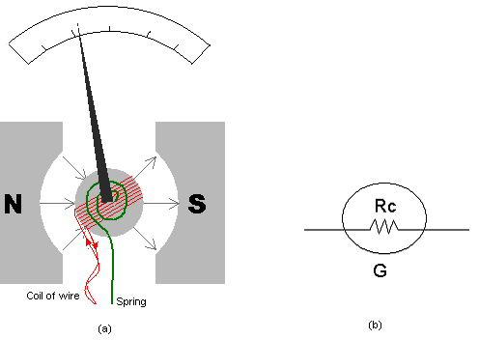
It consists of a magnet, a coil of wire, a spring, a pointer, and a calibrated scale. The coil is mounted in such a way that it can rotate, which causes the pointer to move in relation to the scale. The coil of wire and pointer rotate when there is a current in the wire. The coil rotates in response to the torque applied by the magnet when there is a current in the coil. The coil stops rotating when this torque is balanced by the torque of the spring.
A meter has two important characteristics that must be considered when it is used as part of a measurement device. First, the amount of dc current that causes a full-scale deflection (I) of the pointer indicates the sensitivity of the galvanometer. The second important characteristic is the resistance R_{C} of the wire in the coil. Figure (b) above shows how a meter with a coil resistance of R_{C} is represented in a circuit diagram.
In this lab, first we will measure the full scale current (I) and the internal coil resistance (R_{C}) of a meter. Then we will construct and check a voltmeter and an ammeter.
Answer the following:
1. List 5 components of an analog meter.
2. What function is accomplished by the spring in an analog meter?
3. List two important characteristics of an analog meter.
4. Current can be measured with _________________________.
5. Potential difference or Voltage can be measured with _________________________.
6. A light bulb is connected to a battery. A voltmeter and an ammeter are used to measure the current through and the voltage across the bulb. Show this in a circuit diagram.

7. For the following questions answer high, infinity, low, or zero.
- The resistance of an ideal ammeter is __________________.
- The resistance of a good ammeter is ___________________.
- The resistance of an ideal voltmeter is __________________.
- The resistance of a good voltmeter is ___________________.
7. A galvanometer has a full-scale current of 2.0 mA and a coil resistance of 50.0 .
a. Determine the series resistance necessary to construct a 5-volt voltmeter.
b. Determine the parallel resistance necessary to construct a 0.5 A ammeter.

Procedure:
A) To measure the full scale current (I) and the internal coil resistance (R_{C}):
1. Set up the following circuit. Use power supply (set to about 2 volt), decade resistance box (set to 999-Ω), and DMM as ammeter (set to 10A), and meter.
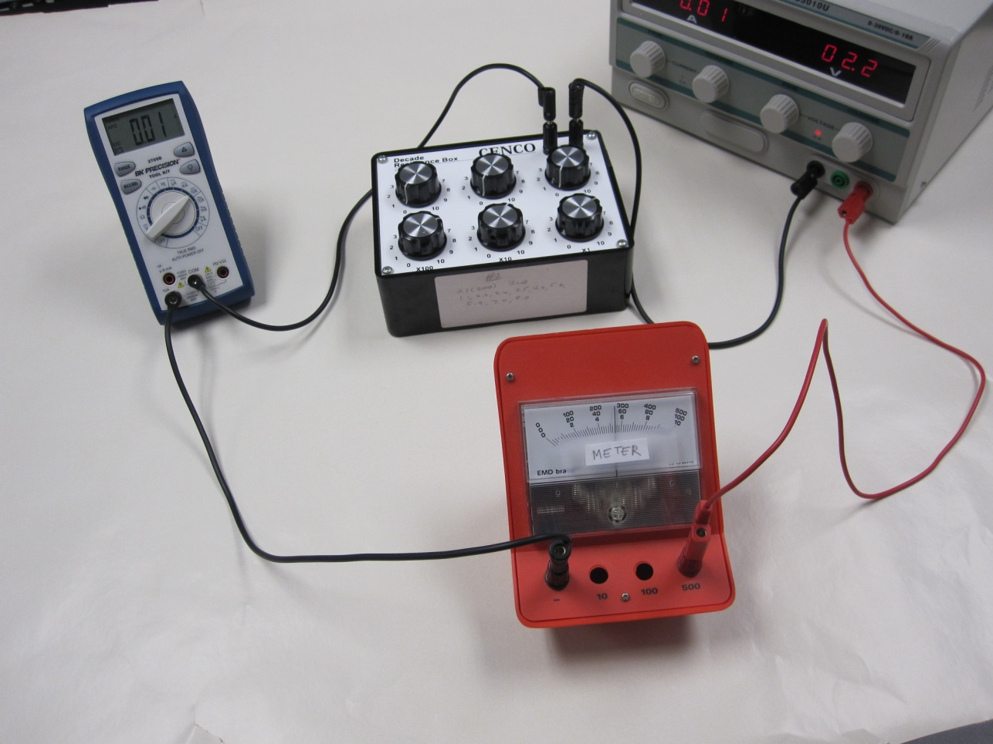
2. Have your construction checked by the instructor.
3. Slowly and carefully lower the resistance until the meter reaches full scale.
4. Measure the full scale current, by switching the DMM to read in mA. Record this full scale current below.
5. Disconnect the circuit and measure the internal coil resistance of the meter using a DMM, by connecting both.
Full scale current of the meter, I = Resistance of the meter, R_{C} =
B) Construction of a voltmeter:
1. A resistance, R_{S} is placed in series with the meter to convert it to a voltmeter as shown below.
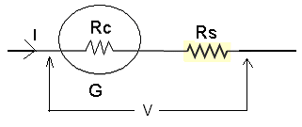
$$V=I(R_{C}+R_{S})$$
2. Calculate the series resistance, R_{S} for a 10-V voltmeter. Use I and R_{C} values you measured from part (A).
R_{S} = _____________
3. To construct the voltmeter; connect the resistance, R_{S} in series with the galvanometer. Use the decade box for R_{S}.
4. While the power supply is unplugged, set up the following circuit and get the construction checked by the instructor, who will plug in the power cord.
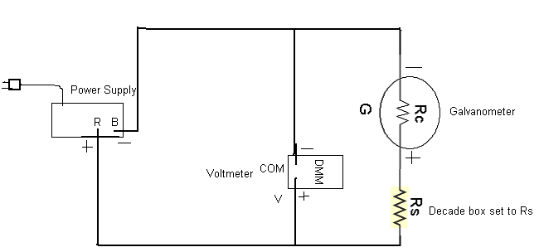
5. The constructed voltmeter should read full scale for 10-volt, if not adjust R_{S}.
6. Change the voltage and complete the following table.
R_{S} = _____________
Voltmeter reading ( V ) | Constructed voltmeter reading
10
8
6
4
2
C) Construction of an ammeter
1. A resistance (R_{P}) is placed in parallel with the galvanometer to convert it to an ammeter as shown below.
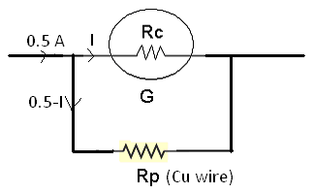$IR_{C}=(0.5-I)R_{p}$
2. Calculate the parallel resistance, R_{P} for a 0.5 A ammeter. R_{p} = _____________
3. Calculate the length (L) in cm of #30-Cu wire required to obtain R_{P}.
L = _____________
Diameter (#30) = 0.02548 cm and resistivity of Cu = 1.72 x 10⁻⁶ Ω.cm.
4. Cut a piece of #30-Cu wire of length (L+2) cm.
5. Construct the ammeter by connecting the Cu wire in parallel with galvanometer, as shown below. The extra 2-cm will be wasted in the connections, 1-cm for each.
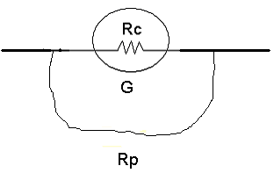
6. While the power supply is unplugged, set up the following circuit to measure currents and get the construction checked by the instructor, who will plug in the power cord.
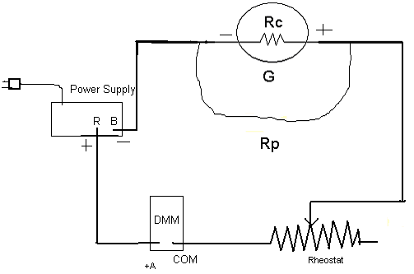
7. The constructed ammeter should deflect full scale for 0.5 A. If not call the instructor who will adjust the length of Cu wire to get full scale deflection.
8. Change the current and complete the following table.
ammeter reading (A) | 0.5 | 0.4 | 0.3 | 0.2 | 0.1
Constructed ammeter reading
9. Conclusion on a separate last page.

