Name:____________________________Date:_______________Time:____________
Partner's Name: ________________________Course:_________________
______________________________________________________________________
Specific Heat and Latent Heat
Purpose: To determine the specific heat of metals and the latent heat of fusion of ice by the method of calorimetry.
A. Specific Heat
Apparatus: Calorimeter and accessories, metal objects (Al & Cu), temperature sensor, PC w/interface, electronic balance, hot plate, beaker, water, and thread.
Theory:
In this experiment the metal object will be heated in boiling water (temperature = 100⁰C) and transferred to the calorimeter cup with water. The rise in temperature will be measured with a temperature sensor. In order to calculate the specific heat you need to derive an expression for the specific heat of the metal, C_{m} in terms of measurable quantities.
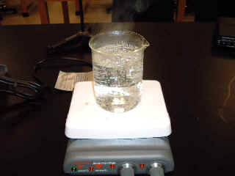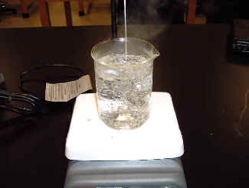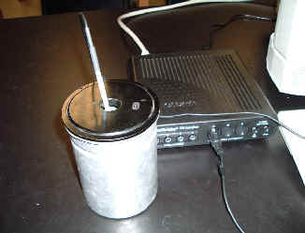
In the space below derive an expression for the specific heat of the metal, C_{m} in terms of the following measurable quantities:
M_{m} = mass of the metal object, temperature of the hot metal (100⁰C), T_{f} = final temperature of the metal object, M_{w} = mass of water, C_{w} = specific heat of water, T_{i} = initial temperature of water, M_{c}= mass of the calorimeter cup, C_{c}= specific heat of the calorimeter cup, T_{f} = final temperature of the calorimeter cup and water.
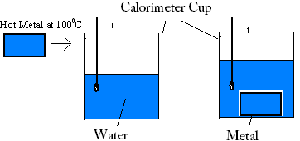

Procedure:
1) Fill the beaker with water (about 2/3 full), place it on the hot plate, and bring the water to boil.
2) Find the mass of a metal object.
3) Find the mass of the calorimeter cup. Get some tap-water (about 1/2 full) in the cup and find the mass of the cup with water.
4) Set the calorimeter cup inside the calorimeter jacket and close the lid.
5) Lower the metal object into the boiling water by means of a thread. Make sure that the metal is completely immersed and not to touch the bottom or sides of the beaker. You need to hold the metal in the boiling water for about 2-3 minutes.
6) While you are holding the metal in the boiling water, let your partner measure the initial temperature of the calorimeter cup and water by following procedures 7 & 8.
7) To measure temperature:
a. Make sure that the power for the interface is turned on.
b. Plug in the temperature sensor to analog input A, white arrow on top.
c. Open PASCO Capstone software from the desktop.
d. Click Hardware Setup under Tools on the left, click on the interface input where the sensor is connected and select Temperature Sensor. Click Hardware Setup again to close it.
e. Double-Click Digits under Displays on the right, click Select Measurement, and select Temperature.
f. Click Record.
8) Place the temperature sensor inside the calorimeter cup and record the initial temperature of the calorimeter cup and water, T_{i}, to the nearest tenth of a degree.
9) Transfer the metal object from the boiling water, quickly to the calorimeter cup. Stir the water and watch the temperature until the temperature peaks. Record this peak temperature. (T_{f})
10) Calculate the specific heat and compare it with the accepted value.
11) If the % error is high consult the instructor.
12) Repeat procedures 2-11 for the other metal object, using fresh tap-water each time.

DATA:
Specific heat of the calorimeter cup material = C_{c} = 0.215 cal/(g.C⁰)
Specific heat of water = 1.0 cal/(g.C⁰)
Mass of the calorimeter cup = M_{c} =_________g.
type of metal……………………….-> | Aluminum | Copper
mass of the metal object, M_{m} | - | -
mass of (calorimeter-cup + water) | - | -
mass of water, M_{w} | - | -
initial temperature of water, T_{i} | - | -
final temperature of water, T_{f} | - | -
calculated specific heat, C_{m} [cal/(g.C⁰)] | - | -
accepted specific heat [cal/(g.C⁰)] | 0.215 | 0.093
percent error | - | -

B. Latent Heat of fusion of Ice
Apparatus: calorimeter with jacket, water, ice cube, temperature sensor, PC w/interface, and, electronic balance.
Theory: In this part ice at 0⁰C (mass M_{i}) will be added to a calorimeter cup (mass M_{c}) with water (mass M_{w}).
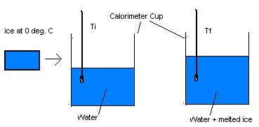
In the space below, derive an expression for the latent heat of fusion of ice,L_{f}.
(Use the following measurable quantities: M_{i} - mass of ice, L_{f} - latent heat of fusion of ice, C_{w} - specific heat of water, T_{f} - final temperature of water, M_{c}- mass of the calorimeter cup, C_{c}- specific heat of the calorimeter cup, T_{i}- initial temperature of the calorimeter cup, T_{f} - final temperature of the calorimeter cup, M_{w}- mass of the water, C_{w}- specific heat of the water, T_{i}- initial temperature of water, T_{f} - final temperature of water)
Procedure:
1) Find the mass of the calorimeter cup.
2) Fill the calorimeter 2/3 full of room temperature water and find the mass of the calorimeter with water.
3) Place the calorimeter cup with water in the calorimeter jacket and put on the lid. Record the temperature of the water, T_{i}, to the nearest tenth of a degree.
4) Add a cube of ice to the water. Watch the temperature while stirring and record the minimum temperature reached, T_{f}. Make sure the ice cube is completely melted.
5) Find the mass of the calorimeter, water, and melted ice.
6) Compute L_{f} and its percent error.
7) Write a combined conclusion for both activities.
DATA
Specific heat of the calorimeter cup
Mass of the calorimeter cup
Mass of the calorimeter cup with water
Mass of water
Initial temperature of water
Final temperature of water
Mass of the calorimeter cup, water, and melted ice
Mass of ice
Calculated Lf
Accepted Lf | 79.7 cal/g
% Error

