PHYS 212 S2012 Study Guide for Test #4 Chapters 27,28,29&30
Test will consist regular questions, derivations, and problems.
1. Chapter Reading.
2. Practice WileyPlus assignments.
Chap 27: 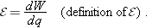
Ohm’s law: v = iR Power:
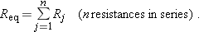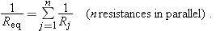
Analyzing circuits using loop rule.
Understanding the behavior of RC circuits.
Chap 28:
Electric force on a charge: $\vec{F}=q\vec{E}$
Magnetic force on a moving charge:
Net force on a moving charge in electric and magnetic fields: $\vec{F}=q\vec{E}+q\vec{v}×\vec{B}$
A Charged Particle Circulating in a Magnetic Field: 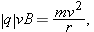
Magnetic Force on a Current-Carrying Wire A straight wire carrying a current i in a uniform magnetic field experiences a sideways force

Chap 29: Magnetic Field of a Long Straight Wire:
Finding magnetic field using Ampere’s law and Biot-Savart law.
Chap 30: Faraday’s law of induction and Lenz’s law.

