PHYS 212 Spring 2012 Study Guide for Test #3 Chapters 24,25, & 26
Test will consist of regular questions and problems.
1. Chapter Reading.
2. Practice WileyPlus assignments.
3. Determining potential due to point charges and continuous charge distributions.
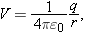 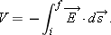 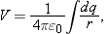
4. Determining the electric field from the potential.
5. Capacitors:
Charge: Stored energy: 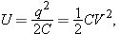
Parallel plate capacitor: $C=\frac{Kϵ_{0}A}{d}$
Capacitors in Parallel and in Series The equivalent capacitances C_{eq} of combinations of individual capacitors connected in parallel and in series can be found from:
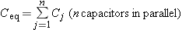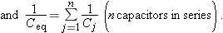
6. Current (i), current density (J), resistance (R), and power (P):
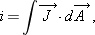
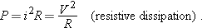
7. Estimating the cost of electricity.
8. Semiconductors and Superconductors.

