PHYS 212 Spring 2014 Study Guide for Test #3 Chapters 25, 26, 27, and 28
Test will consist of regular questions, problems, and derivations.
Chapter 25: Capacitors
Charge: Stored energy: 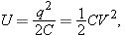
Capacitance of a Parallel plate capacitor: $C=\frac{Kϵ_{0}A}{d}$
Capacitors in Parallel and Series:
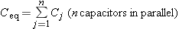 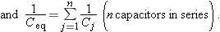
Chapter 26 & 27: Current (i), current density (J), resistance (R), and power (P):
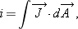
Estimating the cost of electricity. Semiconductors and Superconductors.
Ohm’s law: v = iR Power: 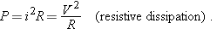

Resistors in Series and in Parallel:
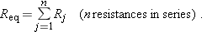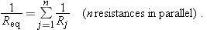
Analyzing circuits using junction rule and loop rule.

Chapter 28:
Electric force on a charge: $\vec{F}=q\vec{E}$ Magnetic force on a moving charge: 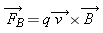
Net force on a moving charge in electric and magnetic fields: $\vec{F}=q\vec{E}+q\vec{v}×\vec{B}$
Vector cross product: $\hat{i}×\hat{j}=\hat{k}$ $\hat{j}×\hat{i}=-\hat{k}$ $\hat{i}×\hat{i}=0$
Vector cross product: $\vec{a}×\vec{b}=ab\sin{θ}$, where θ is the angle between the vectors.
$$a=\sqrt{a_{x}^{2}+a_{y}^{2}+a_{z}^{2}}$$
A Charged Particle Circulating in a Magnetic Field: 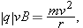
Magnetic Force on a Current-Carrying Wire A straight wire carrying a current i in a uniform magnetic field experiences a sideways force:

