PHYS 212 Spring 2013 Study Guide for Test #3 Chapters 25, 26, & 27
Test will consist of regular questions and problems.
1. Chapter Reading.
2. Practice WileyPlus assignments.
Chapter 25: Capacitors
Charge: Stored energy: 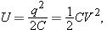
Capacitance of a Parallel plate capacitor: $C=\frac{Kϵ_{0}A}{d}$
Capacitors in Parallel and in Series The equivalent capacitances C_{eq} of combinations of individual capacitors connected in parallel and in series can be found from:
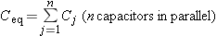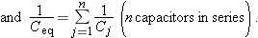
Chapter 26: Current (i), current density (J), resistance (R), and power (P):
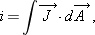
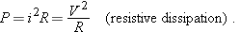
7. Estimating the cost of electricity.
8. Semiconductors and Superconductors.
Chap 27: 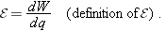
Ohm’s law: v = iR Power:

Resistors in Series and in Parallel:
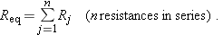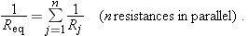
Analyzing circuits using junction rule and loop rule.

