PHYS 212 MWF 9-9:50 S08 Study Guide for Test #1 Chapters 18,19, & 20
Test will consist of multiple choice questions, regular questions, derivations, and problems.
1. Chapter Reading: Find the answers to the chapter opening puzzlers.
2. Laws of Thermodynamics: Zeroth, First, and Second.
3. Thermodynamic processes: Isobaric, Isothermal, Adiabatic, & Isochoric.
4. Derivations: You will be asked to derive one of the following:
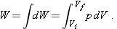
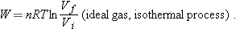
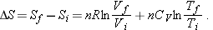
- Problems: Practice WileyPlus assignments. (Equations will be provided)
a. Temperature conversion.
b. Thermal expansion (linear & volume).
c. Calorimetry (absorption of heat by solids & liquids) including that of heat of transformation.
d. Solving problems using ideal gas law including that of isothermal and adiabatic processes.
e. Average, RMS, and most probable speeds of gas molecules.
f. Molar specific heats of an ideal gas.
g. Entropy:
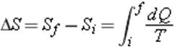
g. Heat engine: Efficiency h. Refrigerator: Coeff. of performance
