PHYS 212 S2012 Study Guide for Final
Final exam will consist of regular questions, derivations, and problems. It will cover the materials from Tests 1, 2, 3, & 4 and Chapters 31, 32, and 33.
Chapters 31, 32, and 33: Practice WileyPlus homework.
AC voltage and transformers, Maxwell’s equations, and Electromagnetic waves.
Study old Test 1:
1. Laws of Thermodynamics: Zeroth, First, and Second.
2. Thermodynamic processes: Isobaric, Isothermal, Adiabatic, & Isochoric.
3. Ideal gas law: PV = nRT; Gas constant = R = 8.315 J/mol.K.
a. Temperature conversion.
b. Thermal expansion (linear & volume).
c. Calorimetry (absorption of heat by solids & liquids) including that of heat of transformation.
Study old Test 2,3,4:
1. Understanding and using Coulomb’s law in problem solving.
2. Understanding and using Gauss’ law in problem solving.
$$ε_{0}\oint{\vec{E}}∙\vec{dA}=q_{enc}$$
3. Defining electric field and deriving the following expression for the magnitude of electric field at a distance r from a point charge, q:
4. Determining strength and polarity of electric charges from electric field lines.
5. Determining the net electric field due to multiple point charges.
6. Determining potential due to point charges and continuous charge distributions.
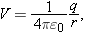 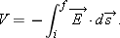 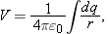
7. Determining the electric field from the potential.
8. Capacitors: Charge: Stored energy: 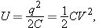
Parallel plate capacitor: $C=\frac{Kϵ_{0}A}{d}$
Capacitors in Parallel and in Series The equivalent capacitances C_{eq} of combinations of individual capacitors connected in parallel and in series can be found from:
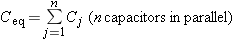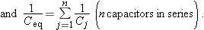
9. Current (i), current density (J), resistance (R), and power (P):
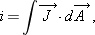
Ohm’s law: v = iR 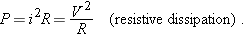
10. Estimating the cost of electricity.
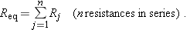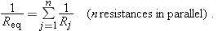
Analyzing circuits using loop rule.
Electric force on a charge: $\vec{F}=q\vec{E}$ Magnetic force on a moving charge:
Net force on a moving charge in electric and magnetic fields: $\vec{F}=q\vec{E}+q\vec{v}×\vec{B}$
A Charged Particle Circulating in a Magnetic Field: 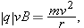
Magnetic Force on a Current-Carrying Wire A straight wire carrying a current i in a uniform magnetic field experiences a sideways force

Magnetic Field of a Long Straight Wire:
Finding magnetic field using Ampere’s law and Biot-Savart law.
Faraday’s law of induction and Lenz’s law.

