PHYS 212 Transformers Name:________________________

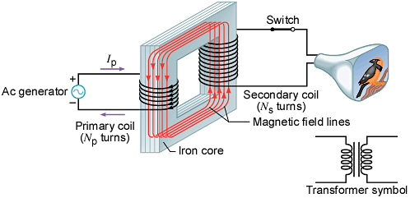

1. Transformer equations are given below. Explain them.

 

2. Under what assumption the above second equation is valid.

3. The transformer shown above is a ____________(step-up or step-down) transformer.

4. A generating station is producing 1.2pixel×pixel106 W of power that is to be sent to a small town located 7.0 km away. Each of the two wires that comprise the transmission line has a resistance per kilometer of length of 5.0pixel×pixel10–2 Ω/km. (a) Find the power lost in heating the wires if the power is transmitted at 1200 V. (b) A 100:1 step-up transformer is used to raise the voltage before the power is transmitted. How much power is now lost in heating the wires? (Power loss in transmission lines,)