PHYS 212 Test #4 Spring 2012 Name:___________________________________
Ohm’s law: v = iR Power: P= vi R in Series = add; R in parallel= R⁻¹=R₁⁻¹+ R₂⁻¹ +R₃⁻¹….
1. In the figure below, an ideal battery of emf = 18 V is connected to a network of resistances R₁ =7 Ω, R₂ = 12 Ω, R₃ = 6 Ω, R₄ = 4 Ω, and R₅ = 5 Ω. What is the potential difference (in V) across resistance 1?

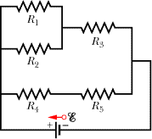

2. In the figure below, the ideal batteries have emfs ε₁ = 10V, ε₂ = 21V, and ε₃ = 5V, and the resistances are each 2.0 Ω.
(a) Determine the current i₁?
(b) What is the power of battery 1?
(c) Does the battery1 supply or absorb energy?
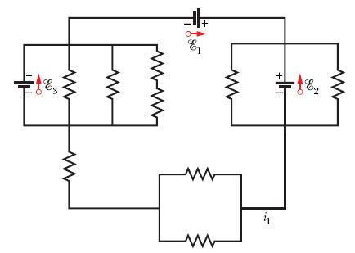

III. A current-length element i produces a differential magnetic field at point P, directed into the page there. Its value is given by Biot-Savart law as follows: (μ₀= 4πx10⁻⁷ T.m/A)
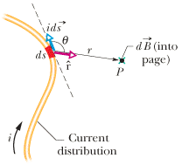

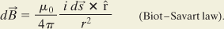

1. Show that the magnetic field at C due to a circular arc of wire is given by the following equation.
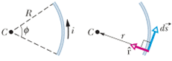
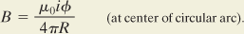

2. In the Figure below, current i = 56.2 mA is set up in a loop having two radial lengths and two semicircles of radii a = 5.72 cm and b = 9.36 cm with a common center P. What are the (a) magnitude and (b) direction (into or out of the page) of the magnetic field at P
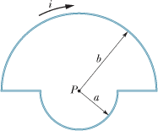

IV. Faraday’s law of induction is given by:
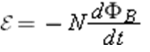
1. In the figure below, the magnetic flux through the loop increases according to the relation Φ_{B} = 4.0t³ + 3.0t², where Φ_{B} is in milliwebers and t is in seconds. What is the magnitude of the emf induced in the loop when t = 3.0 s? 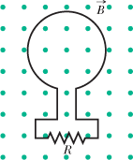

V. A 2.0 μC particle moves through a region containing the magnetic field -20 mT and the electric field 350 V/m. At one instant the velocity of the particle is (5 - 7 + 9 ) km/s. At that instant and in unit-vector notation, what is the net electromagnetic force (the sum of the electric and magnetic forces) on the particle?
(Net force on a moving charge in electric and magnetic fields: $\vec{F}=q\vec{E}+q\vec{v}×\vec{B}$)

