PHYS 212 (11 AM) Test #4 Spring 2012 Name:___________________________________

Ohm’s law: v = iR R in Series = add; R in parallel= R-1=R1-1+ R2-1 +R3-1….

I. Figure below shows a portion of a circuit through which there is a current *I* = 5.0 A. The resistances are *R*1 = 3.0 Ω, *R*2 =6.0 Ω, *R*3 = 5.5 Ω, and *R*4 = 2.5 Ω. What is the current *i*1 (in A) through resistor 1?

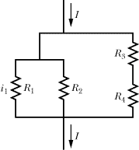

II. In the figure below, the current in resistance 6 is *i*6 = 0.3 A and the resistances are *R*1 = *R*2 = *R*3 = 2.0 Ω, *R*4 = 4.0 Ω, *R*5 = 7.0 Ω, and *R*6 = 3.0 Ω. What is the emf of the ideal battery?

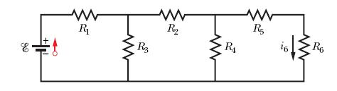

III. To make a galvanometer into a voltmeter, connect a ________________(high or low) resistance in ________________(parallel or series).

IV. The magnetic field due to a long straight wire, carrying a current I, at a distance r is given by;   
(μ0= 4πx10-7 T.m/A)



a. Show the magnetic field, circling the long-wire carrying current I (out of page and into page) using circles with directions, above.

|  |
| --- |
|  |

b. In the figure below, two long straight wires are perpendicular to the page and separated by distance *d*1 = 0.75 cm. Wire 1 carries 6.5 A into the page and wire 2 carries 4.5 A out of the page. What are the (a) magnitude and (b) direction of the net magnetic field due to the two currents at point *P? (d*2 = 1.50 cm from wire 2)

|  |  |
| --- | --- |
|  |  |

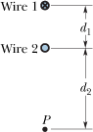

V. Faraday’s law of induction is given by:

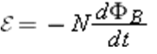

1. Describe the meaning of each term in the above equation including the minus sign.

|  |
| --- |
|  |

2. P7: In the figure below, the magnetic flux through the loop increases according to the relation *ΦB* = 5t4+ 4*t*3 + 3*t*2 + 2*t*, where *ΦB* is in milliwebers and *t* is in seconds. What is the magnitude of the emf induced in the loop when *t* = 2 s?   
 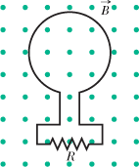

|  |  |  |
| --- | --- | --- |
|  | |  | | --- | | http://edugen.wiley.com/edugen/courses/crs4957/common/art/pixel.gif | |

3. A uniform magnetic field http://edugen.wiley.com/edugen/courses/crs4957/halliday9118/halliday9088c30/math/math002.gifis perpendicular to the plane of a circular wire loop of radius *r*. The magnitude of the field varies with time according to *B* = *B*0*e*-*t/τ*, where *B*0 and *τ* are constants. Find an expression for the emf in the loop as a function of time.

Equations of kinematics: $e=1.6 x {10}^{-19}C$ Electron Mass = 9.11 x 10-31Kg

Final velocity = *v*, Initial velocity = *v0*, Acceleration = *a*, Time interval = *t*, Displacement = *x-x0*

|  |  |  |  |  |
| --- | --- | --- | --- | --- |
| 1. | 2. | 3. | 4. | 5. |
|  |  |  |  |  |

Magnetic force on a moving charge: http://edugen.wiley.com/edugen/courses/crs1650/art/math/halliday8019c28/math153.gif

Newton’s second law: **Fnet** = ma Kinetic energy = $\frac{1}{2}mv^{2}$  
_____________________________________________________________________________VI. At time *t* = 0, an electron with kinetic energy 12 keV moves through *x* = 0 in the positive direction of an *x* axis that is parallel to the horizontal component of Earth's magnetic field http://edugen.wiley.com/edugen/courses/crs4957/halliday9118/halliday9088c28/math/math002.gif. The field's vertical component is downward and has magnitude 55.0 *μ*T.   
(a) What is the magnitude of the electron's acceleration due to http://edugen.wiley.com/edugen/courses/crs4957/halliday9118/halliday9088c28/math/math002.gif?   
(b) What is the electron's distance from the *x* axis when the electron reaches, *x* = 20 cm?