PHYS 212 Spring 2011 Test #3 Name:_____________________________
$V=\frac{kq}{r}$ P = iv = v²/R = i²R Ohm’s law: v = iR $A_{circle}$= π$r^{2}$ $R=ρ\frac{L}{A}$
1. In the figure charges are located along the perimeter of a rectangle
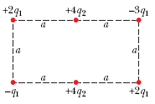
of sides a and 2a. What is the electric potential at the center of the
rectangle? (a = 10 cm, q₁ = 3 µC, and q₂ = 5 µC)

2. A 240 W incandescent light bulb is plugged into a standard 120 V outlet. Assume electrical energy costs US$ 0.08/kW · h.
(a) How much does it cost in dollars per 31-day month to leave the light turned on 1 hour per day?
(b) What is the resistance of the bulb?
(c) What is the current in the bulb?

3. Suppose a kite string of radius 2.00 mm extends directly upward by 0.800 km and is coated with a 0.500 mm layer of water having resistivity 150 Ω.m. If the potential difference between the two ends of the string is 160 MV, what is the current through the water layer?

Capacitor Charge: Stored energy: 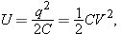 $C=\frac{Kϵ_{0}A}{d}$
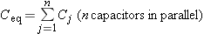 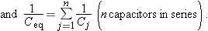______________________________________________________________________________
4. In the Figure, the battery has a potential difference of V = 10.0 V and the five capacitors each have a capacitance of 10.0 μF. What is the charge on (a) capacitor 1 and (b) capacitor 2?
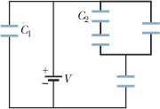

5. Figure below shows a parallel-plate capacitor of plate area A = 10.5 cm² and plate separation 2d = 7.12 mm. The left half of the gap is filled with material of dielectric constant κ₁ = 21.0; the top of the right half is filled with material of dielectric constant κ₂ = 42.0; the bottom of the right half is filled with material of dielectric constant κ₃ = 58.0. What is the capacitance? $(ε_{0}=8.85×{10}^{-12} C^{2}/(N.m^{2})$
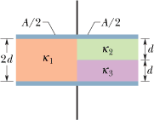

6. The figure here shows a portion of a circuit. What is the current i in the lower right-hand wire? (Include the direction)
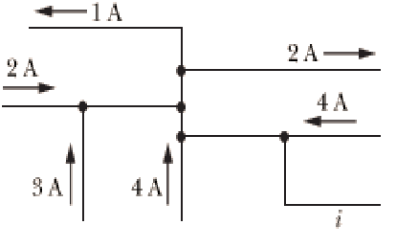

7. What is the electric field in unit vector notation at the point (3i – 6j +k) m if the electric potential is given by V = 3x³yz, where V is in volts and x, y, and z are in meters?

