PHYS 212 Test #2 Spring 2012 Name:___________________________________

You can tear this page and use it as your worksheet.

g = 9.8 m/s2.  Electron Mass = 9.11 x 10-31Kg  
Coulomb’s law is given by,  (k = Coulomb’s constant = 9 × 109 N.m2/C2)  
Electric field at a distance r from a point charge (q) is given by,    
Gauss’ Law is given by, $ε_{0}\oint{\vec{E}}∙\vec{dA}=q_{enc}$. $(ε_{0}=8.85×{10}^{-12} C^{2}/(N.m^{2})$  
Volume of a sphere = $\frac{4}{3}πr^{3}$ Surface of a sphere = 4πr2 Density = Mass/Volume  
Newton’s second law: **Fnet** = ma Centripetal force is given by:   
Avagadro’s number = 6.022 x 1023

PHYS 212 Spring 2011 Test #2 Name:_____________________________

1. Calculate the electric flux (with units) for the 2 cases below, and complete the data table.

|  |  |  |
| --- | --- | --- |
| Electric Field (N/C) | Area vector | Electric Flux |
|  | http://edugen.wiley.com/edugen/shared/assignment/test/session.quest1633132entrance1_N10030.mml?size=14&rnd=1329432384628 |  |
| http://edugen.wiley.com/edugen/shared/assignment/test/session.quest1633132entrance1_N1016B.mml?size=14&rnd=1329432384628 |  |  |

2. In the Figure below, a central particle of charge +q is surrounded by two circular rings of charged particles. What are the magnitude and direction of the net electrostatic force on the central particle due to the other particles? (Express your answer in terms of k, q, r, and R)

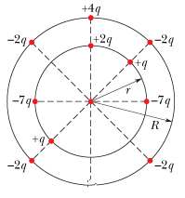

3. A clock face has negative point charges –*q*, –2*q*, –3*q*,..., –12*q* fixed at the positions of the corresponding numerals. The clock hands do not perturb the net field due to the point charges. At what time does the hour hand point in the same direction as the electric field vector at the center of the dial?

4. The cube below has edge length 4.0 m and is oriented as shown in a region of uniform electric field. Find the electric flux through the right face if the electric field is in the positive *y* direction and has magnitude 3.0 N/C.

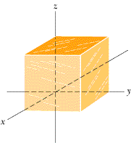

5. In the radioactive decay (see below), a 238U nucleus transforms to 234Th and an ejected 4He. (These are nuclei, not atoms, and thus electrons are not involved.) When the separation between 234Th and 4He is 26.0 × 10-15 m, what are the magnitudes of **(a)** the electrostatic force between them and **(b)** the acceleration of the 4He particle?

92238U --> 90234Th + 24He

6. In crystals of the salt cesium chloride, cesium ions Cs+ form the eight corners of a cube and a chlorine ion Cl- is at the cube's center. The edge length of the cube is *L* = 0.35 nm. The Cs+ ions are each deficient by one electron (and thus each has a charge of +*e*), and the Cl- ion has one excess electron (and thus has a charge of -*e*). If one of the Cs+ ions is missing, the crystal is said to have a *defect*; what is the magnitude of the net electrostatic force exerted on the Cl- ion by the seven remaining Cs+ ions?

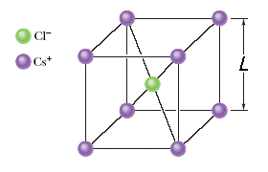

7. In Millikan's experiment, an oil drop of radius 1.73 μm and density 0.859 g/cm3 is suspended in chamber C by means of an electric field of 0.293 × 105 N/C, applied using the battery B.   
a. Show the electric field in the chamber C.  
b. Name the two forces that are acting on the oil drop.   
c. Find the charge on the drop.

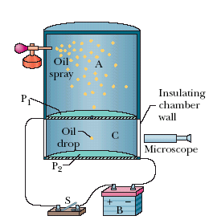

8. In a hydrogen atom the electron orbits the proton at a radius of 5.29 x 10-11 m. Calculate the orbital speed of the electron.

9. In the figure below, a thin glass rod forms a quarter-circle of radius *r*. Charge, q is uniformly distributed along the rod.

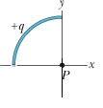  
a. Write down the linear charge density, λ in terms of q, π and r; for the rod. ________________  
b. The magnitude of the electric field at P is given by, $\sqrt{2}\frac{kλ}{r}.$ Show the direction of the electric field at P in the diagram.

|  |  |  |  |  |  |  |
| --- | --- | --- | --- | --- | --- | --- |
| http://edugen.wiley.com/edugen/courses/crs4957/common/art/pixel.gif | |  | | --- | | http://edugen.wiley.com/edugen/courses/crs4957/common/art/pixel.gif | | |  |  |  | | --- | --- | --- | | |  | | --- | | http://edugen.wiley.com/edugen/courses/crs4957/common/art/pixel.gif | |  | | | |

c. Figure below shows three circular arcs centered at the origin of a coordinate system. On each arc, the uniformly distributed charge is given in terms of *Q* = 2.03 µC. The radii are given in terms of *R* = 10.0 cm. What are the **(a)** magnitude and **(b)** direction (relative to the positive *x* direction) of the net electric field at the origin due to the arcs?  
  
