PHYS 212-9AM Spring 2012 Test #1 Name:_____________________________
Show your work explicitly.
A. On a linear X temperature scale, water freezes at -149.0°X and boils at 438.0°X. On a linear Y temperature scale, water freezes at -85.00°Y and boils at -23.00°Y. A temperature of 47.00°Y corresponds to what temperature on the X scale?

The linear coefficient of thermal expansion: α _{concrete} = 12x10⁻⁶(Cº)⁻¹ $∆L=αL_{0}∆T$
B. Concrete sidewalks are always laid in sections, with gaps between each section. For example, the drawing shows four identical 2.4-m sections, the outer two of which are against immovable walls. The three identical gaps between the sections are provided so that thermal expansion will not create the thermal stress that could lead to cracks. What is the minimum gap width necessary to account for an increase in temperature of 32 C°?
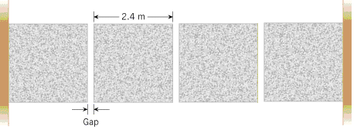

$Q=mc∆T$ $Q=mL$ $dQ=mcdT$ $∆S=S_{f}-S_{i}=\frac{∆Q}{T}=\int_{i}^{f}{\frac{dQ}{T}}$
C. An insulated container contains 200 g of water at 20°C. A lump of aluminum of mass 100 g is heated in boiling water (100°C) and transferred to the water.
(Specific heat: c_{W} = 4180 J/kgK, c_{Al} = 900 J/kgK)
1. What is the equilibrium temperature of the aluminum–water system?
2. What is the entropy change for water?
3. What is the entropy change for aluminum?
4. What is the entropy change for aluminum-water system?

Ideal gas law: PV = nRT; R = 8.315 J/mol.K. First Law of T.D: ΔE_{int} = Q –W
Heat = Q = nCΔT; C_{V}=(3/2)R, C_{p}= C_{V}+R for monatomic gas Efficiency =$\frac{\left|W\right|}{\left|Q_{H}\right|}$
D. Three mol of a monatomic ideal gas initially at a pressure of 3.0 × 10⁵ Pa and volume of 0.02 m³ undergoes the following cycle: (1) heated at constant volume to a pressure of 5.0 × 10⁵ Pa, (2) then allowed to expand at constant pressure to a volume of 0.06 m³, (3) then cooled down at constant volume to the initial pressure, and (4) finally compressed at constant pressure to its initial volume.
(a) Draw a P-V diagram of the cycle.
(b) Identify the paths where heat goes in or out.
(c) The net work done by the gas.
(d) Energy transferred as heat to the gas.
(e) The efficiency of the cycle.

