PHYS 212 Ch-29: Biot-Savart Law Practice for Test
A current-length element i produces a differential magnetic field at point P, directed into the page there. Its value is given by Biot-Savart law as follows:
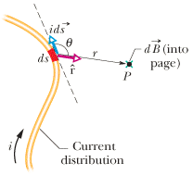

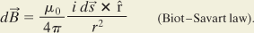

Show that the magnetic field at C due to a circular arc of wire is given by the following equation.
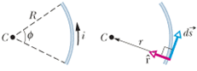
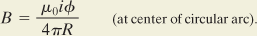

1. (P8) | In Fig. 29-39, two semicircular arcs have radii R₂ = 7.80 cm and R₁ = 3.15 cm, carry current i = 0.281 A, and share the same center of curvature C. What are the (a) magnitude and (b) direction (into or out of the page) of the net magnetic field at C?
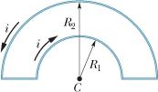
2. (P 64) In Fig. 29-76, a closed loop carries current i = 200 mA. The loop consists of two radial straight wires and two concentric circular arcs of radii 2.00 m and 4.00 m. The angle θ is π/4 rad. What are the (a) magnitude and (b) direction (into or out of the page) of the net magnetic field at the center of curvature P?
