PHYS 212 Mass Spectrometer Name:______________________________  
Electric PE = *qV*   

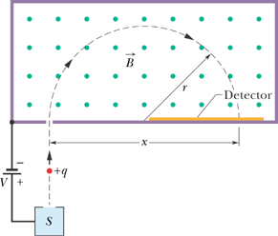

1. Show that the mass is given by:



2. A certain commercial mass spectrometer as shown above is used to separate uranium ions of mass 3.92 x 10-25 kg and charge 3.20 x 10-19 C from related species. The ions are accelerated through a potential difference of 100 kV and then pass into a uniform magnetic field, where they are bent in a path of radius 1.0 m. After traveling through 180° and passing through a slit, they are collected in a cup.   
**(a)** What is the magnitude of the (perpendicular) magnetic field in the separator?  
 If the machine is used to separate out 100 mg of material per hour, calculate   
**(b)** the current (in A) of the desired ions in the machine and   
**(c)** the thermal energy (in J) produced in the cup in 1.0 h.