PHYS 212 Inductors and Inductance
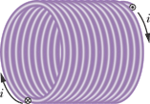 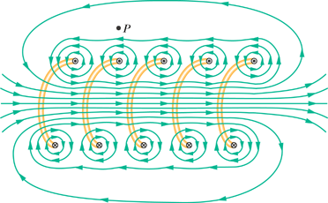
1. Define inductance and express its SI unit.
2. Using Faraday’s law of induction show that the self-induced emf is given by:
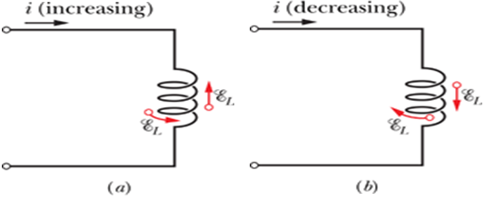
3. Show that the inductance per length for a solenoid is given by:
Inductance—like capacitance—depends only on the geometry of the device.
4. Show that the magnetic energy and magnetic energy density are given by:
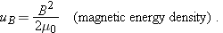
5. RL circuits:
